Termodynamika na webu

Seznam knih:

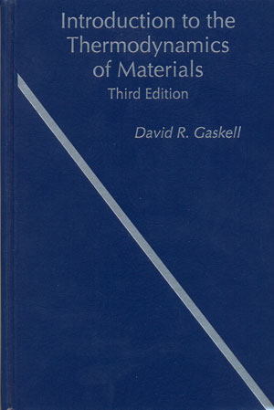
David R. Gaskell
Introduction to the Thermodynamics of Materials
Third Edition
568 str.
Taylor and Francis Group
1995

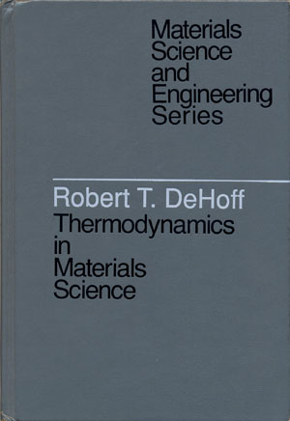
Robert T. DeHoff
Thermodynamics in Materials Science
532 str.
McGraw-Hill
1993
http://www.amazon.com/exec/obidos/tg/detail/-/0070163138/qid=1093353572/sr=1-1/ref=sr_1_1/103-0088314-9739826?v=glance&s=books

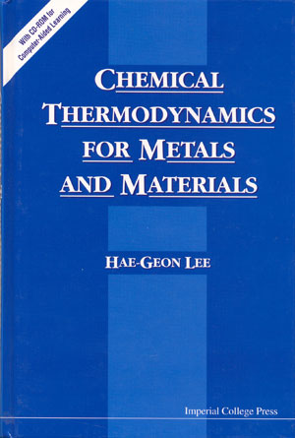
Hae-Geon Lee
Chemical Thermodynamics for Metals and Materials
309 str.
Imperial College Press
1999
http://www.icpress.co.uk/books/engineering/p152.html

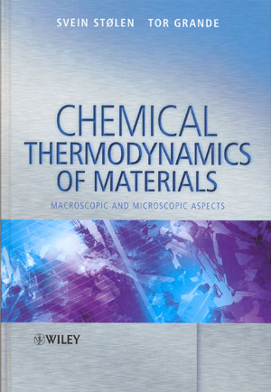
Svein Stolen, Tor Grande
Chemical Thermodynamics of Materials
Macroscopic and microscopic aspects
395 str.
Wiley
2004
http://www3.interscience.wiley.com/cgi-bin/booktoc/109088228

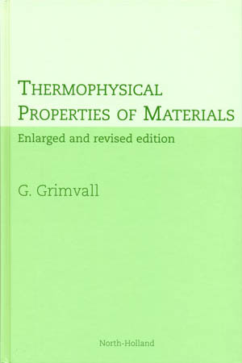
Goran Grimwall
Thermophysical Properties of Materials
424 str.
Elsevier Science
1999
http://www.elsevier.com/wps/find/bookdescription.cws_home/620072/description#description

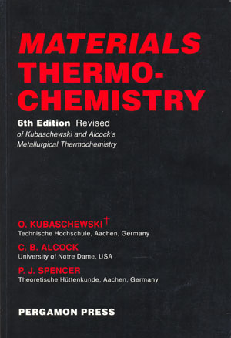
O. Kubaschewski, C. B. Alcock, P. J. Spenser
Materials Thermochemistry
6th Edition Revised
363 str.
Pergamon Press
http://www.cbls.com/detail.jsp?isbn=0080418899

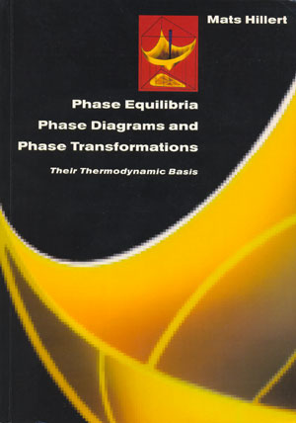
Mats Hillert
Phase Equilibria, Phase Diagrams and Phase Transformations
Their thermodynamic basis
538 str.
Cambridge university press
1998
http://titles.cambridge.org/catalogue.asp?isbn=0521565847

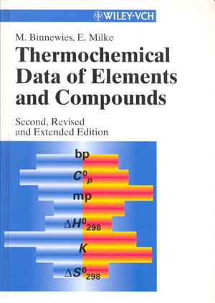

E. Binnewies, E. Milke
Thermochemical Data of Elements and Compounds
Second edition
928 str.
Wiley-VCH
2002
http://www.wiley-vch.de/publish/en/books/bySubjectCH00/ISBN3-527-30524-6/?sID=9331fb1ab4126b7b16d4fcbabada2336

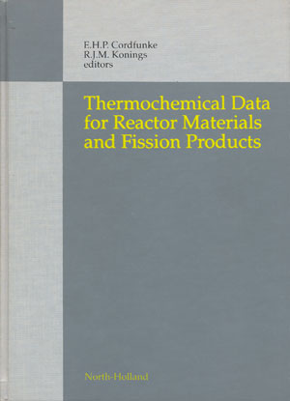

E. H. P. Cordfunke, R. J. M. Konings
Thermochemical Data for Reactor Materials and Fission Products
695 str.
North-Holland
1990

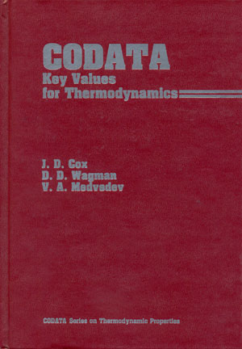

J. D. Cox, D. D. Wagman, V. A. Medvedev
CODATA Key Values for Thermodynamics
271 str.
Hemisphere Publishing Corporation
1989

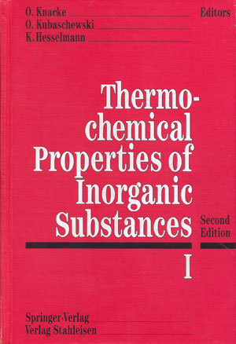
O. Knacke, O. Kubaschewski, K. Hesselmann
Thermochemical Properties of Inorganic Substances
Second Edition
I. a II. díl
2412 str.
Springer Verlag
1991

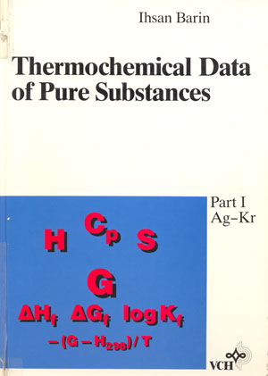
Ihsan Barin
Thermochemical Data of Pure Substances
1739 str.
I. a II. díl
VCH
1992

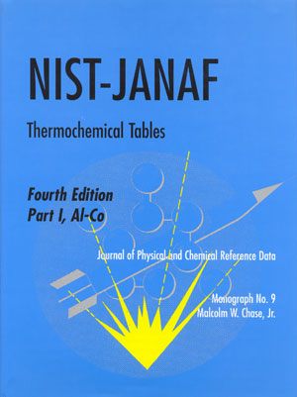
Malcolm W. Chase
NIST-JANAF Thermochemical Tables
Fourth Edition
I. a II. díl
1963 str.
American Chemical Society
1998
http://www.nist.gov/srd/jpcrd_28.htm#janaf

