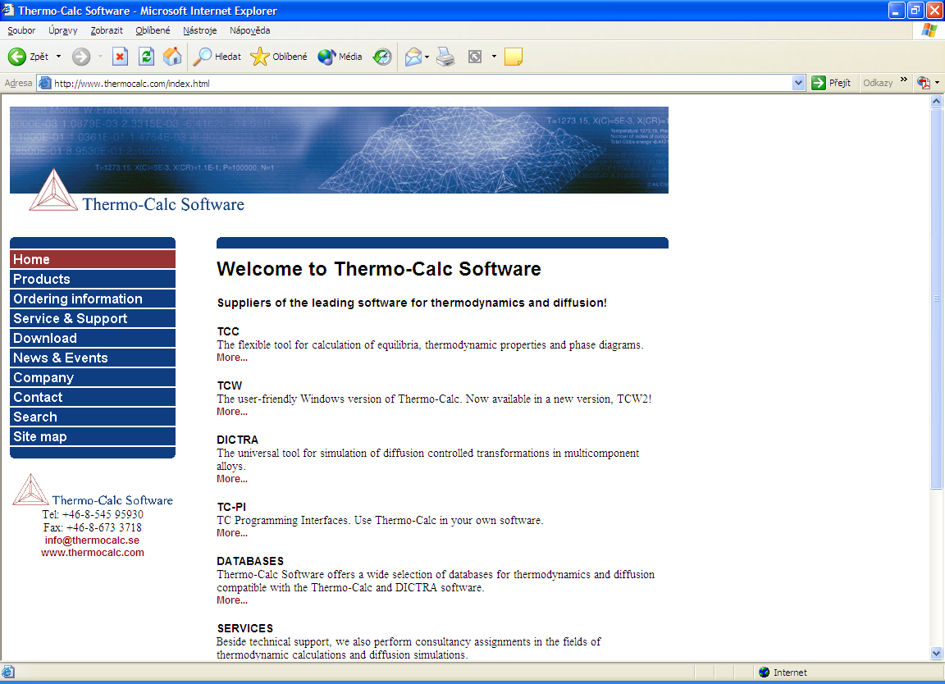 | http://www.thermocalc.com/index.html
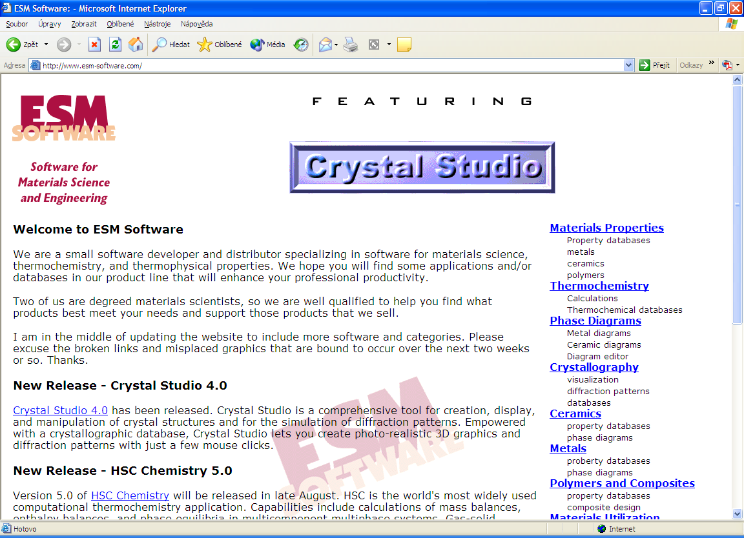 | http://www.esm-software.com/
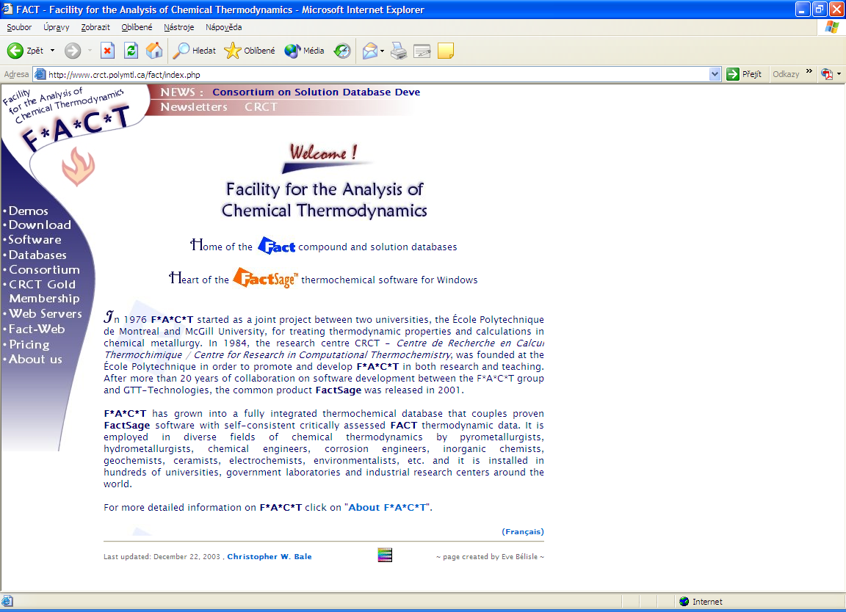 | http://www.crct.polymtl.ca/fact/index.php
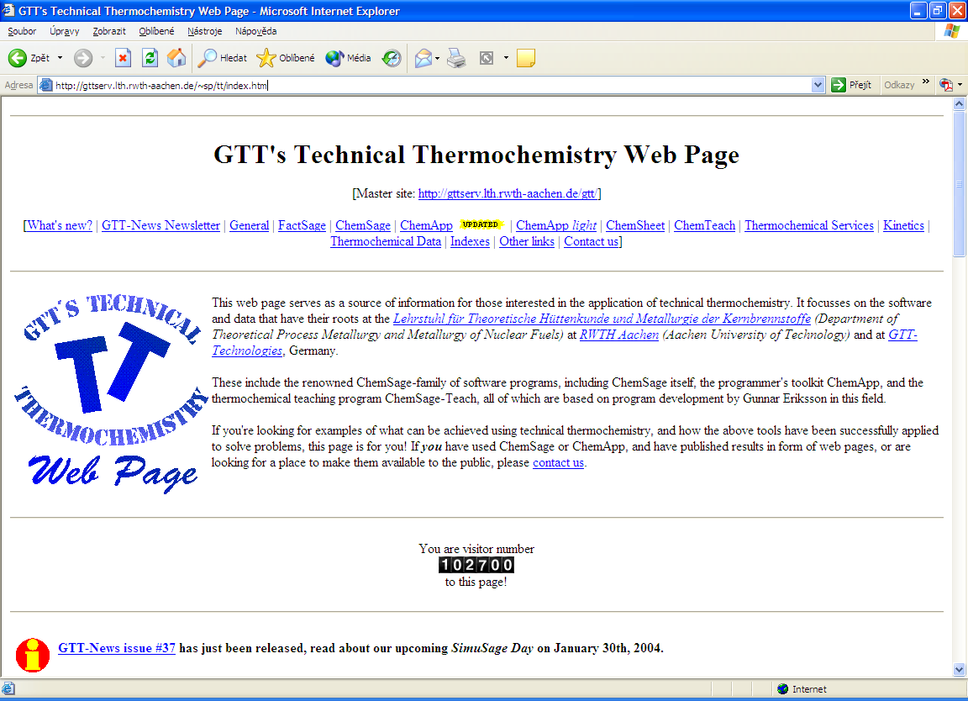 | http://gttserv.lth.rwth-aachen.de/~sp/tt/index.htm
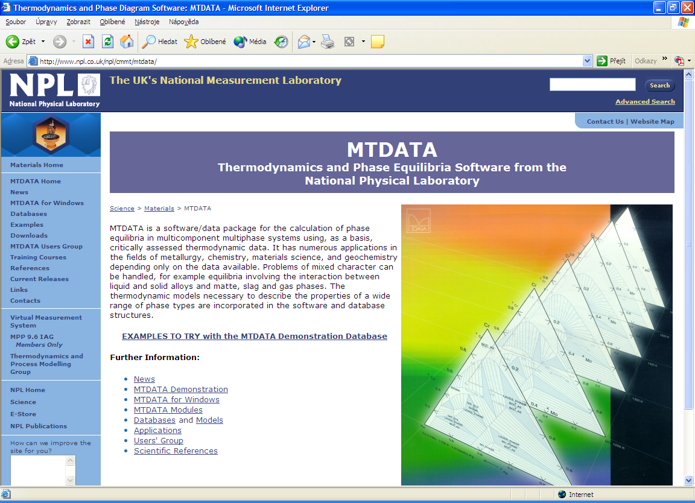 | http://www.npl.co.uk/npl/cmmt/mtdata/
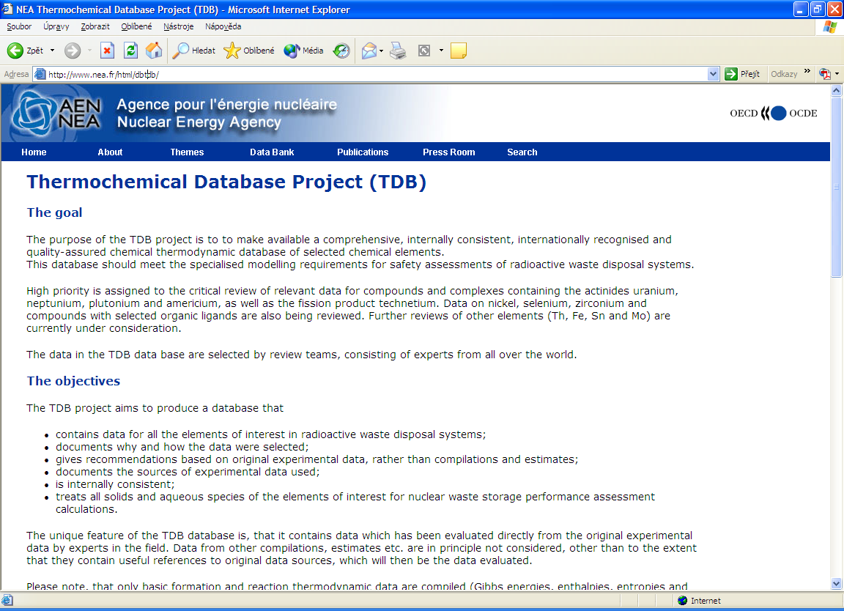 | http://www.nea.fr/html/dbtdb/
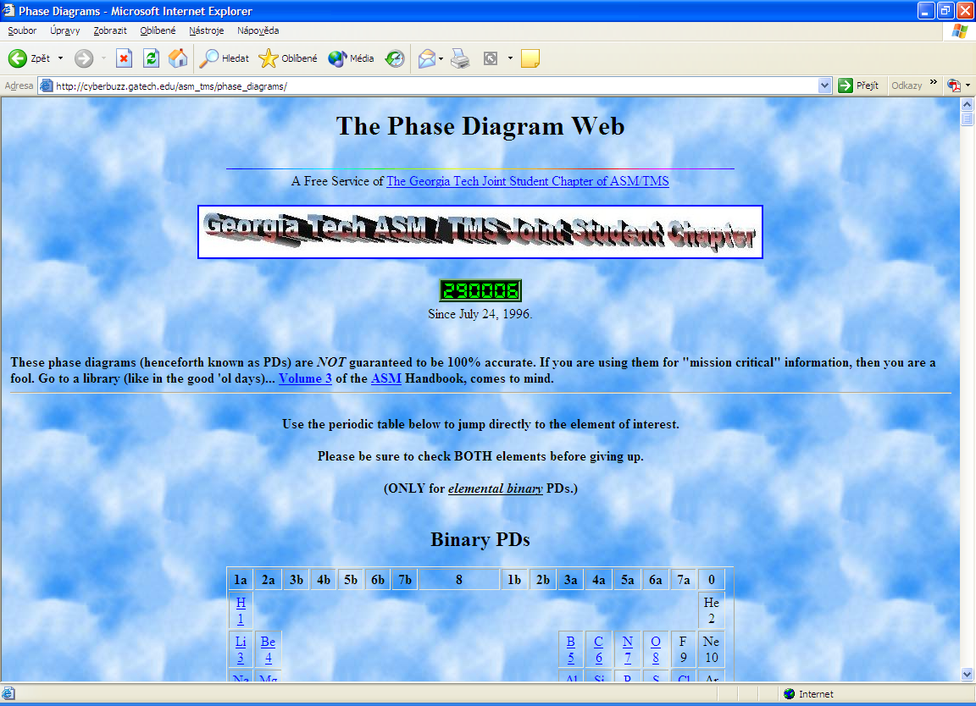 | http://cyberbuzz.gatech.edu/asm_tms/  phase_diagrams/
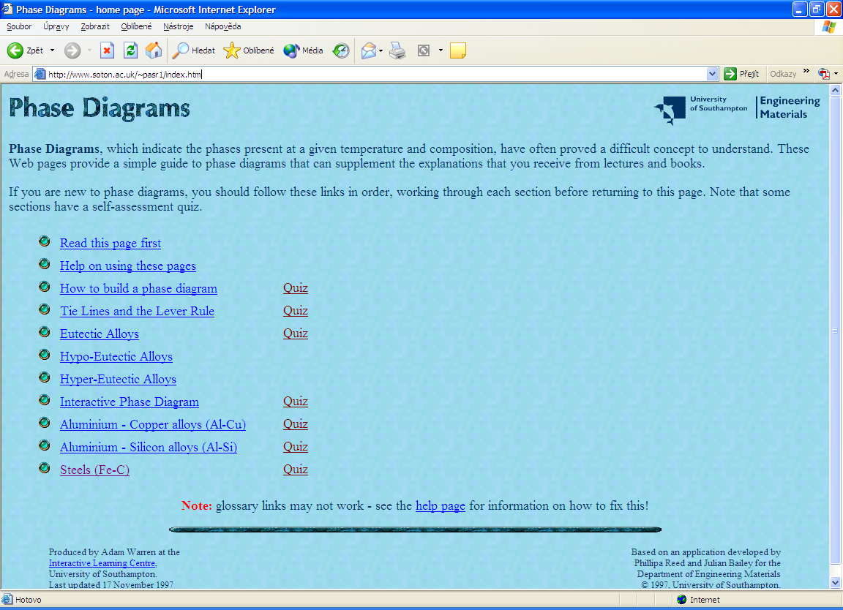 | http://www.soton.ac.uk/~pasr1/index.htm
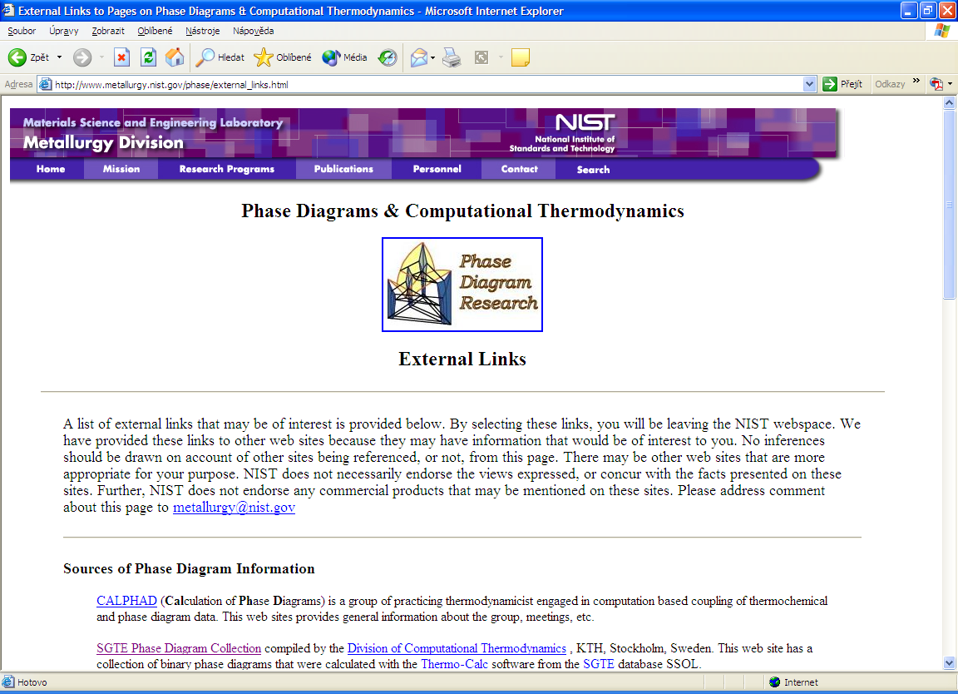 | http://www.metallurgy.nist.gov/phase/  external_links.html
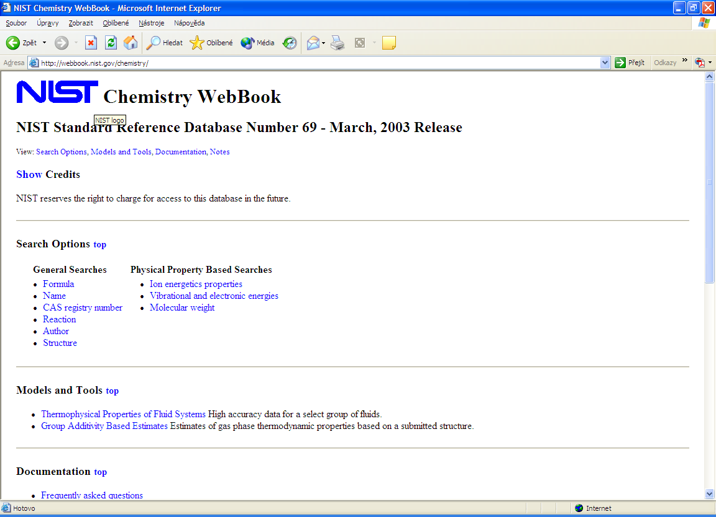 | http://webbook.nist.gov/chemistry/
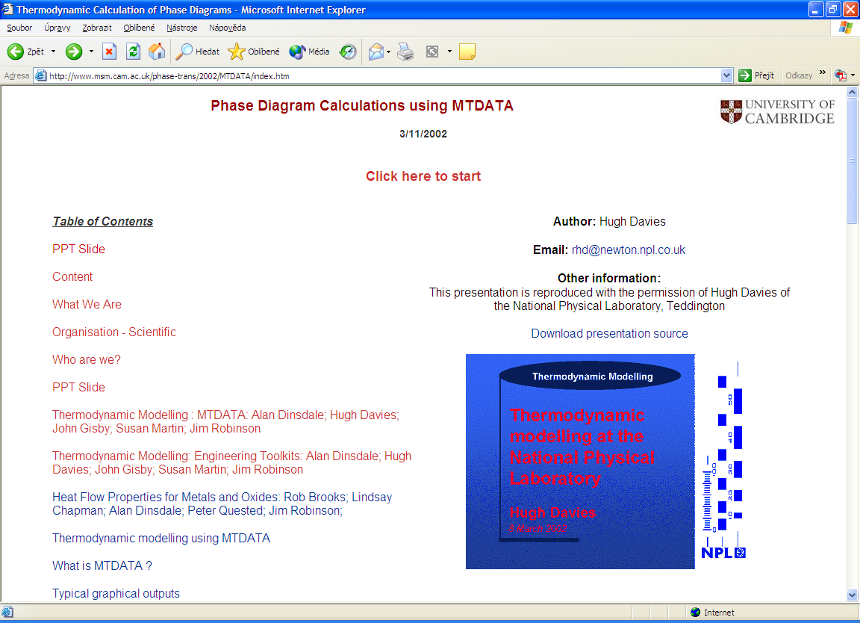 | http://www.msm.cam.ac.uk/phase-trans/2002/MTDATA/index.htm

