ENGLISH
FOR CHEMISTRY STUDENTS 1

Table of contents:

SCHOOL 1/67
CHEMISTRY 18/67
LABORATORY 38/67
ENVIRONMENT 56/67

UNIT 1

SCHOOL

“Stay in college, get the knowledge. And stay there until you’re through. If they can make penicillin out of mouldy bread, they can sure make something out of you.” (Muhammad Ali)

WARM UP

1 Make pairs. Introduce yourself to your partner. Include your name, school department, specialization, your likes and dislikes, where you live, your background and any other information you want to add. Your partner will then briefly introduce you to the rest of the class and vice versa.

2 Discuss the following quotes about education:

“Live as if you were to die tomorrow. Learn as if you were to live forever.” (Mahatma Ghandi)

“Education is the most powerful weapon which you can use to change the world.”
(Nelson Mandela)

“Anyone who stops learning is old, whether at twenty or eighty. Anyone who keeps learning stays young.” (Henry Ford)

“If you think education is expensive, try ignorance.” (Derek Bok)

“Education is the kindling of a flame, not the filling of a vessel.” (Socrates)

“A man who has never gone to school may steal from a freight car; but if he has a university education he may steal the whole railroad.” (Theodore Roosevelt)

3 Answer the following questions:
- What is the official name of our school in English?
- What is the structure of administration?
- Do you know all the position titles?
- Do you know the name of the rector, the head of your department or the head of the language department?
- What are the names of some of your faculty’s departments and subjects?

PRE-READING

4 Find the right definitions for the following expressions:

1. to pursue sth a. utilization, installation, application
2. unique b. to produce
3. to comprise sth c. perfectly, excellently
4. to turn out d. to be made up of, or formed from
5. core courses e. to have as its parts or members
6. total enrolment f. superior, prominent, extraordinary
7. to consist of g. to carry out, make efforts to achieve
8. to subscribe h. to get, acquire
9. to operate i. the number of people registered at an institution/course
10. to provide j. to pay to receive copies of a magazine/newspaper
regularly
11. implementation k. following
12. outstanding l. the only one of its kind
13. to gain m. to give, lend
14. superbly n. modern
15. up-to-date o. central, main, key, most important
16. successive p. to run, control, manage

5 Complete the text about the UCT using the words in the box and read it:

postgraduate degree successive pursuing Master implementation
depth branches outstanding staff unique public provide
superbly Bachelor currently departments enrolment

The Past and the Present of the University of Chemistry and
Technology, Prague


The University of Chemistry and Technology, Prague (UCT) is a ……………. university providing education and ……………. scientific research, development and ……………. activities. The UCT Prague is known for both the ……………. and broadness of its educational and research activities in almost all ……………. of chemistry, chemical engineering, food chemistry and technology, biochemistry, refining, water-treatment, power and biological sciences and technologies, as well as environmental protection, materials sciences and other chemistry-based fields of study.
The UCT Prague turned out a number of ……………. chemists, among them Professor Otto Wichterle, the inventor of soft contact lenses in the 1950s. Vladimír Prelog, professor at the ETH Zürich who won the Nobel Prize for Chemistry in 1975, graduated from the School of Chemical Technology in 1928, and he gained his PhD ……………. there several years later.
The UCT Prague consists of four faculties, Faculty of Chemical Technology, Faculty of Environmental Technology, Faculty of Food and Biochemical Technology, Faculty of Chemical Engineering, and ……………. accommodating the needs of all UCT Faculties.
The UCT Prague ……………. comprises almost 780 ……………., including about 40 professors, 100 associate professors, and 280 assistant professors and assistants. The Faculties of the UCT are accredited to provide three-year Bachelor programmes, ……………. two-year Master programmes (ending with the award of the academic title Engineer), and PhD programmes. The total ……………. at the UCT Prague is about 4525 students.
The UCT Prague operates a ……………. equipped Central Library, which contains more than 100,000 volumes of books, handbooks, encyclopaedias, periodicals and other publications. The Library subscribes to some 300 professional periodicals and has an electronic access to scientific journals.
Several pieces of ……………. and most up-to-date scientific equipment are located in the Central Laboratories, which ……………. services to all Faculties in implementing scientific projects as well as in teaching postgraduate students.
Study programs and branches
The University of Chemistry and Technology, Prague (UCT) offers the following types of study programmes:
a. ……………. programme lasts for three years. Study programmes at all faculties are based on core courses embracing general subjects. Graduates are awarded the title "Bachelor" (equivalent to BSc)
b. ……………. programme links up to BSc programme and takes 2 years. It comprises core and specialized courses. Studies lead to the "engineer" degree ("inženýr" in Czech, equivalent to an MSc)
c. ……………. doctoral studies leading to a PhD degree lasting three years beyond master studies
Note: “Postgraduate”
- Br: relating to studies done after receiving the first university degree (it comprises both master and doctoral programmes),
- Am: relating to studies done after receiving an advanced degree such as MA or PhD.

Bachelor programmes:
FACULTY OF CHEMICHAL TECHNOLOGY
Study programme | Study sub-programme
Applied Chemistry and Materials | Chemistry and Chemical Technologies
Applied Chemistry and Materials | Chemistry and Technology of Materials
Applied Chemistry and Materials | Chemistry and Applied Ecology
Applied Chemistry and Materials | Informatics and Chemistry
Applied Chemistry and Materials | Chemistry of Materials for the Automotive Industry
Drug Synthesis and Production | Drug Synthesis and Production
Conservation-Restoration of Cultural Heritage Objects – Works of Arts and Crafts | Technology of Conservation-Restoration
 | Conservation-Restoration of Metallic Works of Arts and Crafts
 | Conservation-Restoration of Glass and Ceramic Works of Arts and Crafts
 | Conservation-Restoration of Textile Works of Arts and Crafts
Biomaterials for Medical Purposes | Biomaterials for Medical Purposes
Forensic Analysis | Chemistry and Materials in Forensic Analysis

FACULTY OF ENVIRONMENTAL TECHNOLOGY
Study programme | Study sub-programme
Environmental Technology | Environmental Chemistry and Technology
Environmental Technology | Fuel and Environmental Chemistry and Technology
Environmental Technology | Alternative Energies and the Environment
Environmental Technology | Environmental Chemistry and Toxicology
Environmental Technology | Environmental Analytical Chemistry
Forensic Analysis | Chemistry and Materials in Forensic Analysis

FACULTY OF FOOD AND BIOCHEMICAL TECHNOLOGY
Study programme | Study sub-programme
Food and Biochemical Technology | Food Technology
Food and Biochemical Technology | Food Chemistry and Analysis
Food and Biochemical Technology | Biochemistry and Biotechnology
Drug Synthesis and Production | Drug Biotechnology
Forensic Analysis | Chemistry and Materials in Forensic Analysis

FACULTY OF CHEMICAL ENGINEERING
Study programme | Study sub-programme
Engineering and Management | Process Engineering, Informatics and Management
Engineering and Management | Technical, Physical and Analytical Chemistry
Engineering Informatics | Engineering Informatics
Chemistry | Chemistry
Nano- and Micro-Technology in Chemical Engineering | Nano- and Micro-Technology in Chemical Engineering
Drug Synthesis and Production | Drug Analysis

Master programmes:

FACULTY OF CHEMICAL TECHNOLOGY

Chemistry and Chemical Technologies

Chemistry of Materials and Material Engineering

Inorganic, Organic and Macromolecular Chemistry

Drug Synthesis and Production

Conservation-Restoration of Cultural Heritage Objects

FACULTY OF ENVIRONMENTAL TECHNOLOGY

Environmental Technology

FACULTY OF FOOD AND BIOCHEMICAL TECHNOLOGY

Biochemistry and Biotechnology

Food Chemistry and Analysis

Food Technology

Clinical Bioanalytics

Drug Synthesis and Production

FACULTY OF CHEMICAL ENGINEERING

Analytical and Physical Chemistry

Drug Synthesis and Production

Economics and Management of Chemical and Food Co.
Process Engineering and Informatics

Applied Engineering Informatics

PhD programmes:

FACULTY OF CHEMICAL TECHNOLOGY
Chemistry
Chemistry and Chemical Technologies
Chemistry and Technology of Materials
Drug Synthesis and Production

FACULTY OF ENVIRONMENTAL TECHNOLOGY
Environmental Chemistry and Technology
Chemistry and Technology of Fuels and Environment

FACULTY OF FOOD AND BIOCHEMICAL TECHNOLOGY
Chemistry
Microbiology
Biochemistry and Biotechnology
Food Chemistry and Technology
Drug Synthesis and Production

FACULTY OF CHEMICAL ENGINEERING
Chemistry
Chemical and Process Engineering
Applied Mathematics
Drug Synthesis and Production

http://www.vscht.cz/homepage/english/main/university/general_info

COMPREHENSION

6 What are the three main study programmes at the UCT and what degrees do they
lead to?

7 Name the 4 faculties. What’s the name of your field of study?

8 Have you learned anything new or surprising about the UCT?

VOCABULARY AND GRAMMAR

9 Fill in the gaps with appropriate expressions:
consists comprises graduated
including accommodating awarded
subscribes equipped gained
accredited broadness

- The UCT is known for both the depth and ……………… of its educational and research activities in almost all branches of chemistry.
- Vladimír Prelog, professor at the ETH Zürich who won the Nobel Prize for Chemistry in 1975, ……………….. from the School of Chemical Technology in 1928, and he ………………… his PhD degree there several years later.
- The UCT ………………………. of four faculties, Faculty of Chemical Technology, Faculty of Environmental Technology, Faculty of Food and Biochemical Technology, Faculty of Chemical Engineering, and departments …………………… the needs of all UCT Faculties.
- The UCT currently …………………. almost 780 staff, …………………… about 40 professors, 100 associate professors, and 280 assistant professors and assistants.
- The Faculties of the UCT are ………………….. to provide three-year Bachelor programmes, two-year Master programmes and PhD programmes.
- The UCT operates a superbly …………………. Central Library.
- The Library ……………….. to some 300 professional periodicals and has an electronic access to scientific journals.
- Graduates are ………………… the title "Bachelor" (equivalent to BSc)

10 Use the right preposition:
a) The university consists ……….. six faculties.
b) The school laboratory is equipped ……… modern machines and devices.
c) Paul graduated ………. the UCT in 2005.
- The university………. a number of prominent scientists.
- The Library subscribes ………… a large number of professional periodicals.
- The faculty comprises ……….. 8 departments.
- She majored …….. a study programme leading ……… a degree ……… biochemistry.

11 Match the Am and Br English expressions of academic ranking and structure of administration with their definitions:

Associate Professor
Dean Assistant Professor Associate Professor

Professor
President/Chancellor

USA
Registrar/University Treasurer

President

Associate Professor

Department Head/Chair

ProfessorDean
Assistant Professor

Associate Professor
Dean Assistant Professor Associate Professor

Professor
President/Chancellor

UK
LecturerDean

Rector/Chancellor

Department Head/Chair

Professor

Senior Lecturer/Reader

Registrar/University Treasurer

the head of a university =
a person in a university who is in charge of a faculty =
a person in charge of a university department =
the chief official in an academic institution handling financial and student records =
a university teacher of the highest, most prestigious rank, exhausting all normally-expected promotions =
a teacher at a university who has a rank just below the rank of a Professor and who has been granted tenure, i.e. the right to stay permanently in a job, especially as a teacher at a university =
a teacher at a university who has a rank just below the rank of an Associate Professor; the entry-level rank for faculty on the "tenure track" =

12 Fill in the structure of administration:

Associate Professor
Dean Assistant Professor Associate Professor

Professor
President/Chancellor

University
of Chemistry and Technology,
Prague
………………

Vice-Rector for EducationVice-Rector for External Relations and Com.

Vice-Rector for Research and DevelopmentVice-Rector for Strategies and Development

…………..………….. ………….. …………..
FACULTY of FACULTY of FACULTY of FACULTY of
Chemical Technology …………………… ......………………. ....……………….

DEPARTMENT
………………………. ---- Professor
Associate Professor
………………..
Assistant

DISCUSSION

13 Discuss in pairs or small groups:
- Why did you choose to study at the UCT Prague?
- What is the status of the UCT among other Czech universities providing education in chemistry and pursuing scientific research? Why?
- How do you think the UCT would stand in comparison with other universities of a similar focus worldwide? Explain.
- What is essential for a university focused on Chemistry and scientific research to be successful and to offer the best education and future career prospects to their students? How can the success of such institution be measured?
- Can you think of the top 5 world universities providing Chemistry education?
- What makes these academic institutions so successful and prestigious? What do you think are the main differences from the UCT?

HOMEWORK

14 Based on the instructions given by your teacher, look up the information about one of the top 5 universities. Next class you are going to introduce the information and discuss the differences between the University of Chemistry and Technology, Prague and the chosen university. Think in terms of broadness, requirements, courses, degrees, opportunities offered for scientific research/ project participation/ internships, career options, etc. Focus on new vocabulary.

15 Where do you see the advantages/disadvantages of the educational systems of these
universities? Would you like to study at any of these universities? Why?

16 Fill in the table with appropriate forms:
Adjective / Antonym | Noun | Verb
broad
long
 | width
 |  | thicken
high |  | 0
0 0 | weight
short
0 0 |  | grow

DISCUSSION
17 Answer the following questions:
- Have you ever studied abroad? How was it?
- Think of reasons why to take part in Erasmus programme.

ROLEPLAY

18 You are going to act out an interview of a candidate for the Erasmus exchange program. One of you is an interviewer from the school’s Language department and the other one is a student-candidate. Ask and answer questions about the student’s background in chemistry and foreign languages, about his/her intentions and reasons for studying abroad, about the potential school and its system etc.

WRITING

19 Choose one of the following topics:
- Write a magazine article that introduces and promotes UCT Prague in attempt to attract potential future students. When writing, keep in mind the type of readers you are trying to address and the type of information they might appreciate. Should it be formal or informal? Serious or fun?

- Write a letter to a friend stating your intention to study chemistry abroad and explaining the reasons why you want to do so.

VOCABULARY EXERCISES

20 Find words which are described by the following definitions:

a ceremony at which students receive a university degree = ……………………………….
scientific study done in the field, such as measuring and examining things = …………..…
a large hall (in schools) where meals are served = ………………………………..………..
time of rest and recreation away from school = …………………………………..………...
a speech to a group of students, especially as a method of teaching at universities =………
a person who has completed a course of study in college or university = ………………….
21 Explain the meaning of these expressions in English:
term – semester – trimester – seminar – to cram for an exam – to grant a scholarship –
a freshman – undergraduate – gaps in knowledge – to acquire knowledge – exam fever – thesis – a credit – to observe the rules – curriculum

22 Give opposites of the expressions in italics:
summer semester
a private school
successful applicants
compulsory/obligatory subjects
to pass the finals
to be absent
to start the university
major in Chemistry
skip/cut classes
superficial/shallow knowledge
to be expelled/suspended from school
drop a course
sit for/take exams
23 Match verbs with nouns:

DO  GET  TAKE | courses  homework  research  projects  credits  exams  a thesis  an experiment  a degree  a job

24 What are online courses? Who are they designed for and what areas can they be used in? Do you have any personal experience with this form of education? Would you like to enrol on a course of this type? Why (not)? Does UCT offer any “alternative” methods of education? Discuss in pairs or groups.

25 Fill in the appropriate words:

exam test an assignment master's degree in chemical engineering
studies course experiment year education

acquire/get/lack (an) ……………….
design/plan a ……………….
perform/carry out/conduct an ……………….
be in the first, second, etc. ……………….
cheat in/on a ……………….
work on/write/do/submit an ……………….
finish/complete your ……………….
take/do/sit for an ……………….
earn/receive/be awarded a ……………….

26 Number the expressions in what you think is a logical order. Compare with a partner.

__ pass entrance exams
__ participate in an exchange programme
__ apply for a job
__ be admitted to university
__ enrol in/on the course
__ graduate (from) university
__ submit thesis
__ apply to a university
__ fulfill/meet the requirements
__ matriculate (n. matriculation)
__ undertake research
__ set goals

PHRASAL VERBS

27 Complete the sentences with appropriate phrasal verbs and explain their meanings:

hand back look up do over work out go through fill in
hand/turn in fill out catches on keeping up speak up

  - He didn’t know the meaning of the word but didn’t think to ______ it ______ in the dictionary.
  - He ______ ______very quickly. You never have to explain anything twice.
  - Could you please ______ ______? We can’t hear you at the back.
  - I can’t ______ ______ how to do this math problem.
  - Margaret has always had problems ____ ____ with the other students in the class.
  - You did this assignment incorrectly; please ______ it ______.
  - I have to ______ ______ my notes again before the final test.
  - Please ______ ______ your name and ID number here.
  - You need to ______ ______ this application.
  - We have to ______ ______ the essays by next Thursday.
  - He is going to ______ our essays ______ next week.

28 Match the expressions that go together and use them in sentences showing their meanings:
freshman practice/research tuition solid fee
placement continuous laboratory introductory
needs assessment undergraduate admission gap student year (3x) application co-educational
form institution goals/targets/objectives courses policy
career test educational grounding in chemistry academic

29 Work out the crossword:

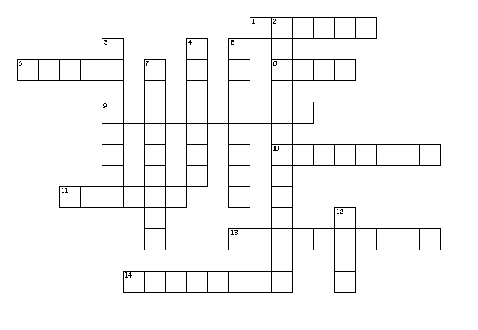
Across
1. engage in or follow up
6. register, enter in a list
8. head of a faculty
9. obligatory
10. careful, systematic or scientific search or inquiry
11. dissertation embodying results of original research
13. award or acceptance of an academic degree
14. include, contain, be made of, constitute

Down
2. student at a college or university studying for a 1st degree
3. optional
4. gain
5. newcomer, 1st year student
7. the act of accepting into a school or organization
12. to be unsuccessful

LISTENING

30 Before listening to the recording, discuss in pairs the following questions:
- What do you know about Chemical Engineering? Can you define it?
- What does a chemical engineer do?

31 How do you understand the following statements about Chemical Engineering?
- It takes chemistry out of the lab into the field
- It is the broadest branch of engineering
- It provides education on the job
- It is a career full of variety

32 Match these words with their definitions:
1 impacted a) meet, experience
2 comprehend b) competences, abilities
3 encounter c) implant
4 require d) enhance
5 specifically e) affected, influenced
6 improve f) get, receive, achieve
7 mass-produce g) decrease, drop
8 remediation h) need, demand
9 capabilities i) improving or correcting something, stopping damage
10 acquire j) understand
11 instil k) produce in large quantities
12 decline l) particularly

33 Match words to make collocations:
1 scope a) methods
2 to overcome b) chemicals
3 draw upon/on c) level
4 efficient d) problems
5 cost e) hours
6 synthetic f) sites
7 to process g) operations
8 industrial h) growth
9 monitor or direct i) fibres
10 longer j) of work
11 entry k) seekers
12 employment l) effective
13 construction m) plants
14 job n) knowledge
34 Listen to the recording about Chemical Engineering and answer the questions:

1. What fields do chemical engineers work in?

2. Except for “making things”, where else is their expertise applied?

3. What places do they work at?

4. What are the working hours of chemical engineers?

5. What is required for almost all entry level chemical engineering jobs?

6. What dual purpose does the core curriculum of chemical engineering programme serve?

7. What types of courses might you take in the 3rd year?

8. What is ABET?

9. What is the average entry level salary that you could expect to earn with the degree in
chemical engineering?

10. What are the employment opportunities?

11. What’s the expected employment growth over the projection decade of 2006 through
2016?

12. What area among manufacturing industries may provide the best opportunities for job
seekers?

13. What areas are expected to show the highest employment growth?

35 Which of these characteristics should a chemical engineer have? Explain why.
patient, funny, good interpersonal and communication skills, optimistic, creative, flexible, talkative, punctual, ambitious, competitive, cooperative

DISCUSSION
36 Discuss in pairs or groups:
- What areas of chemical engineering do you consider the most interesting/important?
- How does chemical engineering differ from your field of study?
- Would you like to be a chemical engineer? Why? Why not?

ROLEPLAY

37 Act out a job interview with an applicant for the post of a chemical engineer at a chosen field/branch. First discuss the specifics of the post, workplace and requirements for the position.

WRITING

38 Write a short essay discussing what field of chemistry you would like to specialize in and why.

GRAMMAR LINKS

39 Refresh your knowledge of the word order and tenses in English sentences by referring to the Grammar File.

UNIT 2

CHEMISTRY

1 Complete the text about chemistry using the words in the box.

bind | charge | science
nucleus | interactions | shape
mass | particles | matter
density | substances | amounts
ions | molecules

Chemistry is the that systematically studies the composition, properties and activity of _______________ and various elementary forms of________________ .
Chemistry is the study of matter and energy and interactions between them.
Energy has no or form. Matter is everything that occupies space and has
. refers to the amount of matter in a given amount of space and is defined as the mass per unit of a substance.
The fundamental building block of matter is the atom. It has a at its centre consisting of protons, which have a positive electrical __________, and neutrons which are uncharged. Negatively charged electrons circle around nuclei. There are super-small ______________ inside the protons and neutrons called quarks.
Chemical reactions involve between the electrons of one atom and the electrons of another atom. Atoms which have different _____________ of electrons and protons have positive or negative electrical charge and are called __________. When atoms _________ together, they can make larger building blocks of matter called ____________.

2 Answer the following questions.

. How would you define chemistry?
. What was your first encounter with chemistry?
. What is/isn't interesting about chemistry for you?
. Which branch of chemistry would you like to specialize in?
. Name some branches of applied chemistry.
. Which sciences are closely connected to chemistry?
. Do you know any Nobel laureate in chemistry?
. Which skills should a chemist have?
. Where can you find a job as a chemist?
. Name some products which don´t exist without chemistry.
. What does organic/inorganic chemistry study?

3 Form the words and explain their meaning in English. Try to use all these words in
one sentence.

CHEM ___ ___ ___ ___ ___ (noun)

___ ___ ___ ___ (noun)

___ ___ ___ (noun)

___ ___ ___ ___ (adjective)

4 Match the definitions of the form of matter and then fill in the chart.

a) a system of two or more chemical substances which are not chemically bound
b) anything that occupies space and has mass
c) a substance formed by the combination of elements in fixed proportions to form a knew
substance by chemical reactions
d) a substance that cannot be decomposed into simpler substances by chemical reactions
e) a single pure form of matter

1. matter 2. substance 3. element 4. compound 5. mixture

5 Form collocations with an adjective chemical and use them in sentences.
The first one is done for you.

chemical a) a statement containing chemical symbols used to show the changes that
happen during a chemical reaction
b) the ways in which substance behaves in different circumstances
c) the process in which the structure of atoms and molecules that make up
a substance are changed
d) the way of representing a substance using the symbols of its elements
e) a scientific test done in order to discover if something works or is true
f) a general statement that is confirmed by observation

6 There are three basic states of matter below.

a) Describe them (fill in the gaps) using adjective definite and its antonym.

solids = ____________________ shape and volume

gases = ____________________ shape and volume

liquids = __________________ shape but ___________________________ volume

b) Name other phases.
c) Explain the difference between a chemical change and a physical change.
d) Study the following table and complete the missing adjectives and verbs.

noun | adjective | verb
solid
liquid
gas

7 Complete the text, the first letters are given in bold.
The temperature at which a solid becomes a liquid is its m______________ p_________
and the point at which a liquid becomes a gas is its b _________________ p ________ .
When a gas or liquid becomes a solid, it s ______________ . When a gas or solid becomes
a liquid, it l __________________ . When a substance becomes a gas or v ____________,
it e ______________ or v ________________; if it returns to its previous state, it
c_____________.

8 Explain the following expressions:

1. irreversible reaction
2. a source of heat
3. trace amount
4. poisonous vapours
5. to be utilized by the body

9 Choose the correct alternative to complete the definitions.

1. a substance that increases the rate of a chemical reaction without itself being changed is a
a) inhibitor b) synthesiser c) catalyst

2. a liquid that dissolves substances is a
a) solvent b) solute c) solubility

3. a substance that allows heat or electricity to go through it is a
a) conductor b) detector c) condenser

4. a small amount of a substance that is used for scientific tests is a
a) trace b) sample c) drop

5. a liquid with another substance dissolved in it, so it has become part of the liquid is a
a) solution b) dilution c) desiccation

6. a liquid mixed with water or another liquid to make it less strong is
a) intact b) soluble c) dilute

10 Pronounce properly the following words. Check your knowledge of their meaning.

acid, acidic, alkali, aqueous, arrangement, atom, binary, Celsius, Centigrade, chemistry, chemical, density, to determine, to distinguish, equation, equilibrium, hormone, to ionize, isotope, nuclei, to occur, occurrence, pressure, procedure, pure, substance, surface, structure, technique, technology, vacuum, valency, to weigh

11 Fill in the missing prepositions.

1. Water boils _____ 100° C.
2. You should lower the temperature ____ several degrees.
3. _______ these conditions the reaction doesn´t occur.
4. Which Czech scientists have been awarded Nobel Prize _____ chemistry?
5. Air is composed mainly _____ nitrogen and oxygen.
6. Chemical equilibrium may be classified _____ two groups.
7. What is capable _____ accepting a proton from another substance?
8. Solar power is the conversion of the sun´s energy ______ heat and electricity.
9. Neutrons are not electrically attracted ___ either electrons or protons.
10. I´m a chemist ____ profession.
11. I want to specialize____ biochemistry.
12. His thesis deals ______ nanomaterials.

12 Form adjectives from the nouns given below and use them in the following
sentences.
mole, science, molecule, density, atom, metal

1. To explore solids and liquids at the ____________ and ______________ level,
we need to look inside them.

2. Helium is a non-metal, although the ending –ium is usually reserved for _______________ elements.

3. Plutonium is very ____________________.

4. We need to adopt a more _______________ approach to this problem.

5. What is a ________________ weight of carbon?

13 Form antonyms.

abundant element ______________ effective method __________________

soluble salts ___________________ to absorb light ___________________

divisible particle ________________ volatile gas ______________________

practical research _______________ to increase temperature _____________

miscible with water _____________ pure substance____________________

stable equilibrium ______________ organic chemistry _________________

diluted solution _______________ to heat a substance _________________

similar properties _______________ thin layer ________________________

14 Put the stages in the scientific method in the correct order (number them 1-8).
a) Describe what the scientist must do using the connectors first/next/then/finally.
b) Form nouns from these eight verbs.

__ define the question __ collect/gather data
__ analyse data __ interpret data
__ draw conclusions __ conduct/carry out/perform an experiment
__ form a hypothesis __ design an experiment

15 Discuss acids, bases, alkalis.

a) Complete the following definitions.

An acid is a compound that contains ___________ and dissolves in water to produce
____________ hydrogen ions.

A base is a compound which reacts with an acid to form _________ and ________ only.

An alkali is a base that _______________ in water to give ________________ ions.

b) What do the terms strong and weak acid refer to?

c) How do acids and bases change the colour of a litmus paper?

d) Form adjectives which mean containing acid, base, alkali.

e) Form nouns describing the quality of being acid, base, alkali.

16 Complete the information about oxidation and reduction.

a) Form the definition of oxidation and reduction using a mnemonic device OILRIG.
(oil rig = a large piece of equipment for getting oil from under sea)

oxidation is _________________________________

reduction is _________________________________

b) Study the following table and complete the missing adjectives and verbs.
noun | adjective | verb
oxidation
reduction

c) Explain the terms oxidant and reductant.

d) What is a redox reaction?

17 Read the text about periodic table and then answer the questions.
People have known about elements like carbon and gold since ancient time. The elements couldn't be changed using any chemical method. Each element has a unique number of protons. If you examine samples of iron and silver, you can't tell how many protons the atoms have. However, you can tell the elements apart because they have different properties. You might notice there are more similarities between iron and silver than between iron and oxygen. Could there be a way to organize the elements so you could tell at a glance which ones had similar properties?
Dmitri Mendeleyev was the first scientist to create a periodic table of the elements similar to the one we use today. This table showed that when the elements were ordered by increasing atomic weight, a pattern appeared where properties of the elements repeated periodically. This periodic table is a chart that groups the elements according to their similar properties.
Remember changing the number of protons changes the atomic number, which is the number of the element. When you look at the modern periodic table, do you see any skipped atomic numbers that would be undiscovered elements? New elements today aren't discovered. They are made. You can still use the periodic table to predict the properties of these new elements.
The periodic table helps predict some properties of the elements compared to each other. Atom size decreases as you move from left to right across the table and increases as you move down a column. The energy required to remove an electron from an atom increases as you move from left to right and decreases as you move down a column. The ability to form a chemical bond increases as you move from left to right and decreases as you move down a column.
The most important difference between Mendeleyev's table and today's table is that the modern table is organized by increasing atomic number, not increasing atomic weight. Why was the table changed? In 1914, Henry Moseley learned you could experimentally determine the atomic numbers of elements. Before that, atomic numbers were just the order of elements based on increasing atomic weight. Once atomic numbers had significance, the periodic table was reorganized.
Elements in the periodic table are arranged in periods (rows) and groups (columns). Atomic number increases as you move across a row or period.
Rows of elements are called periods. The period number of an element signifies the highest unexcited energy level for an electron in that element. The number of elements in a period increases as you move down the periodic table because there are more sublevels per level as the energy level of the atom increases.
Columns of elements help define element groups. Elements within a group share several common properties. Groups are elements which have the same outer electron arrangement. The outer electrons are called valence electrons. Because they have the same number of valence electrons, elements in a group share similar chemical properties. The Roman numerals listed above each group are the usual number of valence electrons. For example, a group VA element will have 5 valence electrons.
There are two sets of groups. The group A elements are called the representative elements. The group B elements are the nonrepresentative elements.
Each square on the periodic table gives information about an element. On many printed periodic tables you can find an element's symbol, atomic number, and atomic weight.
Elements are classified according to their properties. The major categories of elements are the metals, nonmetals, and metalloids (semi-metals).
You see metals every day. Aluminium foil is a metal. Gold and silver are metals. If someone asks you whether an element is a metal, metalloid, or non-metal and you don't know the answer, guess that it's a metal.
Metals share some common properties. They are lustrous (shiny), malleable (can be hammered), and are good conductors of heat and electricity. These properties result from the ability to easily move the electrons in the outer shells of metal atoms.
Most elements are metals. There are so many metals, they are divided into groups: alkali metals, alkaline earth metals, and transition metals. The transition metals can be divided into smaller groups, such as the lanthanides and actinides.

Questions:

1. Describe Mendeleyev´s periodic table. Do you know what he predicted?
2. How are the elements arranged in the modern-day periodic table?
3. What is the periodic table divided into?
4. What are group 1 elements called?
5. What are group 2 elements called?
6. What are group 17 elements called?
7. What are group 18 elements called?
8. Name some properties of metals.
9. Describe semi-metals.
10. Describe non-metals.

18 Study the naming of elements in English and solve the crossword.
actinium - Ac  aluminum - Al  americium Am  antimony - Sb  argon - Ar  arsenic - As  astatine - At  barium - Ba  berkelium - Bk  beryllium - Be  bismuth - Bi  boron - B  bromine - Br  cadmium - Cd  caesium - Cs  calcium - Ca | californium - Cf  carbon - C  cerium - Ce  chlorine - Cl  chromium - Cr  cobalt - Co  copper - Cu  curium - Cm  dysprosium - Dy  einsteinium - Es  erbium - Er  europium - Eu  fermium - Fm  fluorine - F  francium - Fr  gadolinium - Gd | gallium - Ga  germanium - Ge  gold - Au  hafnium - Hf  helium - He  holmium - Ho  hydrogen - H  indium - In  iodine - I  iridium - Ir  Iron - Fe  krypton - Kr  lanthanum - La  lawrencium - Lr  lead - Pb  lithium - Li | lutetium - Lu  magnesium - Mg  manganese - Mn  meitnerium - Mt  mendelevium - Md  mercury - Hg  molybdenum - Mo  neodymium - Nd  neon - Ne  neptunium - Np  nickel - Ni  niobium - Nb  nitrogen - N  nobelium - No  osmium - Os  oxygen - O | palladium - Pd  phosphorus - P  platinum - Pt  plutonium - Pu  polonium - Po  potassium - K  praseodymium - Pr  promethium - Pm  protactinium - Pa  radium - Ra  radon - Rn  rhenium - Re  rhodium - Rh  rubidium - Rb  ruthenium - Ru  samarium - Sm | scandium - Sc  selenium - Se  silicon - Si  silver - Ag  sodium - Na  strontium - Sr  sulphur - S  tantalum - Ta  technetium - Tc  tellurium - Te  terbium - Tb  thallium - Tl  thorium - Th  thulium - Tm  tin - Sn  titanium - Ti | tungsten - W  unnilhexium - Unh  unniloctium - Uno  unnilpentium - Unp  unnilquadium - Unq  unnilseptium - Uns  uranium - U  vanadium - V  xenon - Xe  ytterbium - Yb  yttrium - Y  zinc - Zn  zirconium - Zr

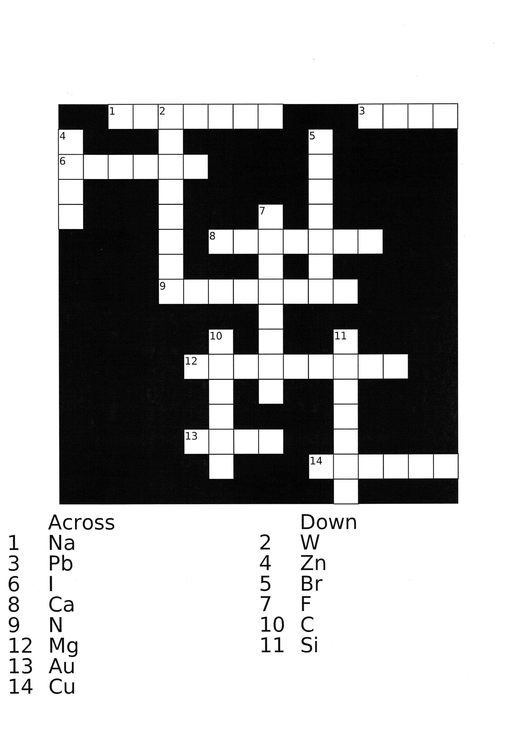

19 Discuss elements.

- Describe one element to your partner and let him/her guess which one it is.
Focus on the following points:

physical and chemical properties, occurrence in nature, laboratory preparation,
industrial production, use of the element and its compounds

b) Which element/s do you consider the most important and why?

c) Pronounce the following elements and think of their symbols.
bromine, calcium, carbon, chlorine, iodine, lead, magnesium, manganese, mercury
neon, nitrogen, oxygen, potassium, radium, sodium, uranium, xenon

20 Listen to the podcasts and do the following exercises.

- silver
Answer the questions:

1. Name three properties of silver: l __ __ __ __ __ __ __ , s __ __ __, p __ __ __ __ __ __ .

2. Where did people obtain silver in ancient times? What did they use it for?

3. Why must silver be cleaned?

4. Which property of silver was essential in the development of photography?

5. Which compound did Henry Talbot use?

6. Which property of silver is important in digital photography?

7. Where can silver toxicity help people?

b) helium
Decide whether the statements are true or false:

1. Helium is an element which occurs in abundance on Earth.
2. Helium is found underground.
3. Alpha particle occurs in a helium atom.
4. Helium is older than the Earth.
5. Helium makes up the biggest part of the mass of the Sun.
6. Lockyer was the first scientist who detected helium on Earth.
7. Helium is an inert gas.
8. Pure helium can help babies with breathing problems.
9. The boiling point of liquid helium is extremely low.

21 Study the nomenclature of inorganic chemistry.
Basics of English inorganic chemistry nomenclature

Naming binary compounds

These are compounds consisting of two elements.
The second name ends with the suffix –ide (chloride, oxide, etc.).
The formation of the whole name of the substance depends on whether or not the given binary compound contains a metal. If it contains a semimetal, the rules are the same as for metals.
When a compound contains a metal, e.g. FeCl₂, the so-called stock system is used, where the basic form of the first element (in this case iron) and the number of its oxidation state (identified by a Roman numeral) are followed by the second element ending with the suffix –ide. Thus, FeCl₂ is written as iron (II) chloride, which is read as “iron two chloride“. The older system, which today remains only in technical names, used the endings –ic or –ous, the former referring to a higher oxidation state and the latter to a lower one. Therefore, FeCl₂ could also be called ferrous chloride (compare with FeCl₃ = ferric chloride). However, this system now only prevails in the nomenclature of oxoacids and their salts and will hopefully soon disappear altogether, as it requires knowing what oxidation states the given element actually achieves before it can be used. In conclusion, endings –ous and –ic are still used in technical names, usually in the combination with the Latin name of the given element, but the stock system (which uses the English names of elements whenever possible) is strongly preferred for the systematic naming of inorganic binary compounds containing either a metal or a semimetal.
When the binary compound contains neither a metal nor a semimetal, write the basic form of both the first and the second element and use the Latin prefixes mono-, di-, tri-, etc., to express the real number of atoms (not the oxidation state!). CO₂ is therefore called carbon dioxide. Similarly, N₂O₃ is then called dinitrogen trioxide, etc.
The main difference is that if a binary compound contains a metal or a semimetal, it has Roman numerals after the name of the first element to express its oxidation state, whereas if there is no metal or semimetal in a binary compound, Latin prefixes express the real amount of atoms and are placed in front of the name of the relevant element.

Nomenclature of acids

Nonoxygenous acids
These acids are without oxygen.
For example, HCl – hydrogen is expressed by the prefix hydro- and the name of the main element ending with the suffix –ic because they are only in one form (hydrochloric acid), or the same rule applies as for binary non-metallic compounds (hydrogen chloride). Likewise, HF can either be called hydrofluoric acid or hydrogen fluoride.

Oxoacids
They contain hydrogen, an element forming their name, and oxygen.
This is the case of the older and rather unfortunate way of naming substances, which was briefly mentioned in the chapter about naming binary compounds containing a metal. As you may remember, it uses the endings –ic or –ous, the former referring to a higher oxidation state and the latter to a lower one. Accordingly, H₂SO₄ is called sulphuric acid (higher oxidation state of sulphur) and H₂SO₃ sulphurous acid (lower oxidation state). The problem is that you need to know what oxidation states that element really achieves or, more precisely, which oxoacids it really forms. Unfortunately, substances are still named using this system, although the IUPAC (an organisation that sets rules for the nomenclature) is taking steps to change it.

If an element forms more than two oxoacids, the prefixes hypo- and per- are employed.

So e.g. HClO is hypochlorous acid (hypo- refers to a lower oxidation state than the one
marked with the ending –ous)
HClO₂ is chlorous acid

HClO₃ is chloric acid (-ic referring to a higher oxidation state than –ous)

HClO₄ is perchloric acid (per- meaning a higher oxidation state than an acid with
the suffix –ic at the end)

Salts of oxoacids are formed in a very similar way (using partly the older method and partly the stock system). Once you know the name of the acid, simply change its ending: –ous into –ite, and –ic into –ate.

Oxidation state | Cations and acids | Anions
Lowest | hypo- -ous | hypo- -ite
 | -ous | -ite
 | -ic | -ate
Highest | per- -ic | per- -ate

Thus, for example, NaClO is called natrium hypochlorite (the name of the element is natrium /sodium and the name of the acid is hypochlorous, so just change its ending from –ous to –ite).
Fe(ClO₃)₂ is called iron (II) chlorate (mark the oxidation state of iron in the same way as in the stock system of binary compounds with a metal, then take the name of chloric acid (HClO₃) and change its ending from –ic to –ate).

22 Name the following compounds:
N₂O₃
CuCl₂
H₂CO₃
CaCO₃
KNO₃
Fe(OH)₃ ____________
HF
KOH

23 Create formulae of the following compounds:
iron (II) oxide
hydrobromic acid
bromic acid
sulphuric acid
diphosphorus pentaoxide
carbon (mono)oxide
sulphur tetraiodide
lead (II) iodide

24 Match the chemical formulae with the correct name and the definition:

1) MgO citric acid a) it is a white crystalline solid; it is a major
chemical in the world and one of the most
damaging salts in structure conservation; the
hydrate is known as Glauber´s Salt

2) HCl acetylene b) in the lower atmosphere is an air pollutant
with harmful effects on the respiratory
systems of animals, it can burn sensitive
plants; it is a pale blue gas soluble in water

3) CaCl₂ sodium chloride c) it is used for relief of heartburn and sore
stomach ; to improve symptoms of
indigestion

4) CO₂ sodium sulphate d) it is a colourless gas which forms white
fumes ; skin contact can cause redness,
pain, severe skin burns

5) C₂H₂ trioxygen e) it is a weak organic acid and a natural
preservative; it is also used to add an
acidic, or sour taste to food and soft
drinks; it exists in a variety of fruits

6) NaCl magnesium oxide f) it is a colourless gas widely used as a
fuel; it is mainly manufactured by the
particial combustion of methane; it has
explosive character and ability to poison

7) Na₂SO₄ ethanol g) it is solid at room temperature; it can be
produced directly from limestone; as an
ingredient it is listed as a permitted food
additive in EU as E509

8) O₃ hydrogen chloride h) it is a gas at standard temperature and
pressure; it exists in Earth´s atmosphere
in this state; it is known as a part of
photosynthesis

9) C₂H₅OH calcium chloride i) it is essential for animal life in small
quantities; it can be harmful to animals
and plants in excess; it is used for food
preservation

10) C₆H₈O₇ carbon dioxide j) it is also called pure alcohol; it is
a flammable, colourless liquid, known as
an essential solvent; it is used in
medicine, food industry, etc.

25 Study mathematical terms, units, symbols.

Calculations
9 + 2 = nine plus two equals / is equal to
20 – 7 = twenty minus seven equals / is equal to
4 x 36 = four multiplied by thirty-six/four times thirty-six equals / is equal to
10 : 5 = ten divided by five equals / is equal to
= log base a of x equals / is equal to

Powers and roots
x² x squared
x³ x cubed
x⁴ x to the power (of) four / x to the four / x to the fourth (power)
x⁻⁵ x to the power (of) minus five / x to the minus five / x to the minus fifth (power)
the square root of x
the cube root of x
the n^{th} root of x

Numbers
100 a / one hundred
101 a hundred and one and is often left out in AmE
4,938 four thousand nine hundred and thirty-eight
5,405 five thousand four hundred and five

Ordinals
1st the first
2nd the second
3rd the third
24th the twenty-fourth

Decimals
0.25 nought / zero point two five After the point, say numbers separately.

Fractions
a / one half
five halves
a / one third
two thirds
a / one quarter
a / one fifth
three sevenths
twenty-seven over two hundred Complex fractions are usually said with over.
a over b

Percentages
27 % twenty-seven per cent

Temperature
95° C ninety-five degrees Celsius/Centigrade
13° F thirteen degrees Fahrenheit

Units
mol mole
mol/dm³ a mole per cubic decimetre / AmE decimeter
ml millilitre / AmE milliliter

Symbols
( ) round brackets
[ ] square brackets
{} curly brackets
(A+B) open brackets, A plus B, close brackets / A+B in brackets
A < B A is less than B
A > B A is greater than B
A ≠ B A is not equal to B
A ≈ B A is approximately equal to B
→ give(s), lead(s) to, yield(s)
↔ forms and is formed from
A capital A
a small a
x₂ subscript
x² superscript

p₁V₁ = p₂V₂ small p subscript one capital V subscript one equals small p subscript two capital
V subscript two

Chemical formulae can also be read with the help of spelling:
e.g. 2 Na₂S could be read as two molecules of [en ei tu: es]

26 Read the following expressions.

25,326 58th 1.012 15,123,014 7⁶ 100°C 11.019

5 H₂O 3 H₂SO₃ 8% 2 KClO₃ → 2 KCl + 3 O₂ 14⁻²

9 mol/dm³ 5 Cu (NO₃)₂

27 Read the article and do the following exercises:

- Make collocations used in the article.

1. cell a patterns
2. marine b technologies
3. UV c field
4. solar d nanostructures
5. new e walls
6. silica f algae
7. to diffract g radiation
8. magnetic h light
9. multilayer i crystals
10. photonic j energy

1 __ 2 __ 3 __ 4 __ 5 __ 6 __ 7 __ 8 __ 9 __ 10 __

- Fill in the missing prepositions. You can consult the article.

- ___ a scale of around 100 nm
- rely ___ nanoscale effects
- seen ___ nature
- studied ___ researchers
- 100-200 nm ___ size
- ___ the University of Utah ___ 2008
- ___ any angle
- work ____ the lab
- made ____ crystals
10. coated ____ a layer

- Scan through the article and find synonyms of the following expressions in the given paragraphs:

1. to be supposed (par 1)
2. actually (par 1)
3. effectively (par 4,5)
4. making possible (par 5)
5. cleared away (par 7)
6. to manufacture (par 8)
7. to start, to launch (par 12)

- Form antonyms of the following words from the article:

- natural
- better
- dim
- strong
- useful
- exactly
- visible
- commonly
- inner

- In the article find the words corresponding to the following definitions:

- very simple, usually very small plants that live in or near water; they have no roots, stems
or leaves
- the outer part of an object
- a set of animals or plants in which the members have similar characteristics to each other
- having an empty space inside

- Form other parts of speech from the words used in the article.

- are assumed noun:
- are discovering noun:
- occurs noun:
- developing noun:
- diffract noun:
- a damage verb:
- applications verb:
- reflectance verb:
- a cell adjective:
10. nature adjective:

- Summarize the article.

28 Unscramble the nouns below and explain their meaning in English.
The first letter is given.

1. cipipretant p______________ 3. rivadetive d_________________
2. antcatre r__________________ 4. mopocnent c_________________

29 Explain the jokes about chemists and chemistry.

question: Why are chemists good at solving problems?
answer: They have all the solutions.

question: If H-two-O is the formula for water, what is the formula for ice?
answer: H-two-O cubed.

teacher: “What is the formula for water?”
student: “H,I,J,K,L,M,N,O”
teacher: “That´s not what I taught you! ”
student: “But you said the formula for water was H – to – O. ”

A chemist walks into a pharmacy and asks the pharmacist:
“Do you have any acetylsalicylic acid?”
“Do you mean aspirin?” asked the pharmacist.
“That´s it, I can never remember the word.” answered the chemist.

teacher: “What does HNO₃ signify?”
student: “Well, …ah, … I´ve got it right on the tip of my tongue.”
teacher: “Well, you had better spit it out.”

Why did the white bear dissolve in water?
Because it was polar.

GRAMMAR LINKS

30 Study two sections of the Grammar File - Passive voice and Relative clauses.

UNIT 3

LABORATORY

WARM UP

1 What comes to your mind when you hear the word laboratory?
Do you know the names of any items you can see below and which can be found in a common chemical laboratory? What are they used for? Fill in the gaps with the words given.

flask (2x), shield, goggles, watchglass, chemicals, graduated cylinder, vessel,
measure, protect, hold, mixing

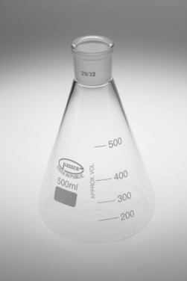
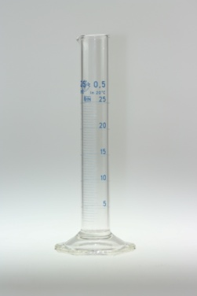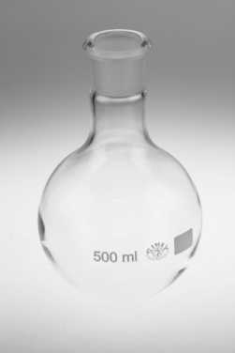

The ……….. ………... The …….. is used The Erlenmeyer ……..
is used to …………….. e.g. to ………….. is used as a mixing
the volume of liquids in ml. liquids during heating. vessel or a container.

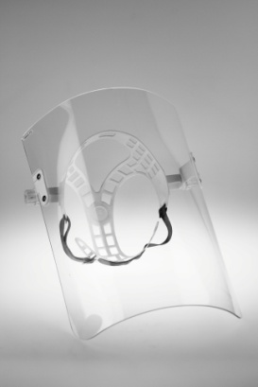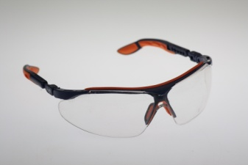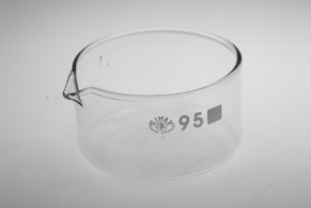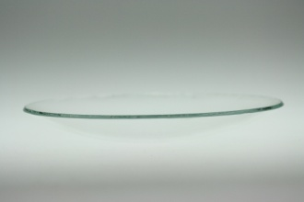

The ……… is used The ……… are used This ……… is used The ………….. can
to protect your face to …….. your eyes for ……... or holding be used as a beaker
from broken glass, chemicals. cover or for heating
chemicals and flames. or evaporating ……..

containers, test tube, crucible, spot plate, evaporating dish, graduated, pipets/pipettes, thermometer, beakers, temperature, filtering flask, stirring rod, measurements, funnel, pour, observing

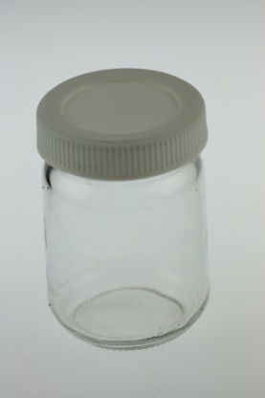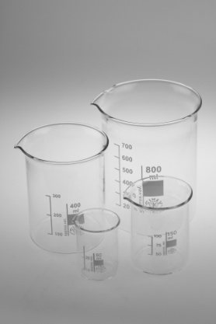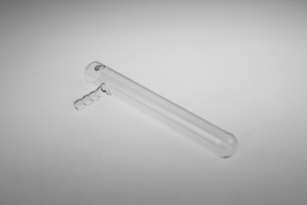

The …….. is used …………. are used …….. are used for The …… …… is used
to remove undissolved for storing chemicals. mixing or holding to hold chemicals
solids from a liquid chemicals. They give during heating or other
mixture or to help only approximate reactions.
…… a liquid into a ……………. of
container. volume.

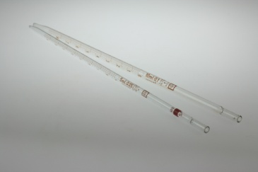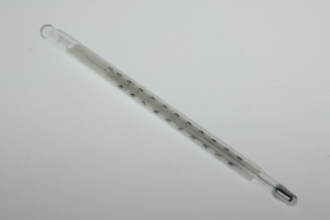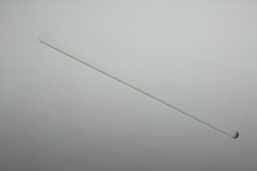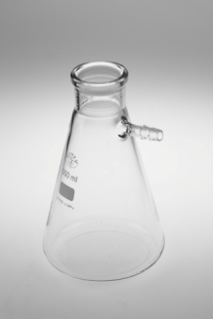

……….. are used to The …… measures The ………….. ….. is The ……. …..
measure liquids. …………….. . used to stir chemicals. can speed up
Volumetric pipets are used filtration.
to measure one amount only.
………pipets measure many
different amounts.

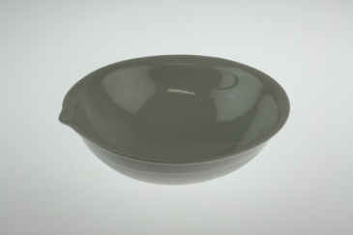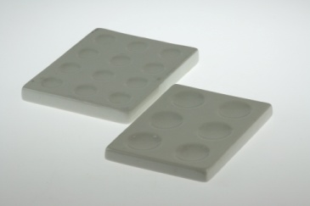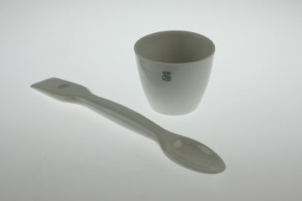

The ………. ……. is used The …….. ….. is used The ………. is used during heating
to evaporate a liquid from for ………… reactions at high temperatures. You can use it
some chemicals. that occur in the wells. with a cover to keep oxygen out of
the reaction. (Next to it is a spatula)

mortar, pestle, ring stand, test tube rack (stand), burner, forceps/tweezers, wash bottle, crucible tongs, test tube clamp, ring clamp, wire gauze, ring stand/tripod, gloves, clay triangle, pick up, ignite, heating, spreads, rinse, support, crush, grind
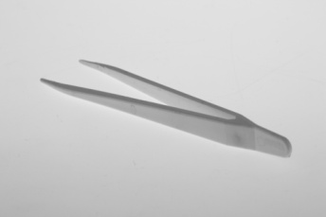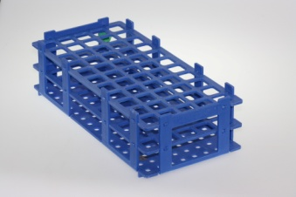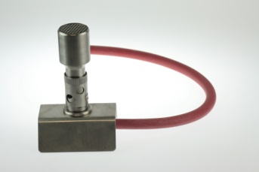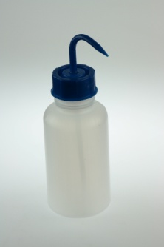

………. are used to …. .. The ……. ……. …..… The ……… is used for ……. The …. …… is small items. supports the test tubes. We might use the flint lighter used to ….. to ……….. the flame. glassware.

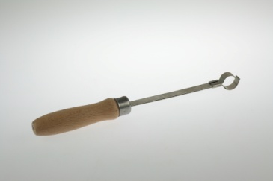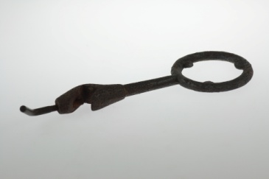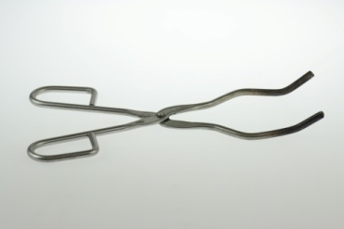

The …. ….. ….. holds a The ….. …… is used to hold .… …… are used to pick up
test tube during heating. e.g. a funnel during filtering. and hold a crucible or any hot objects.

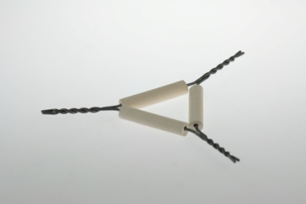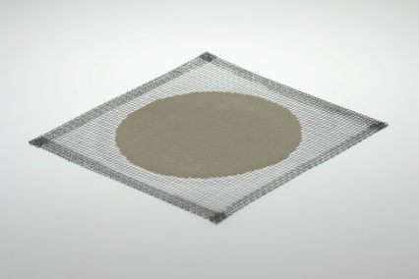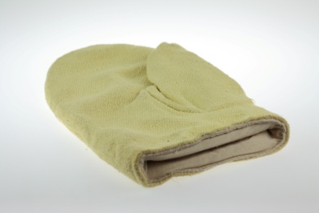

The ….. …… is used to support The …. ……. can support a beaker ….……. are used to
or hold a crucible during heating or a flask during heating. protect our hands.
or a funnel during filtering. It ……. the flame evenly.

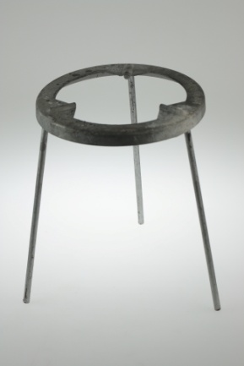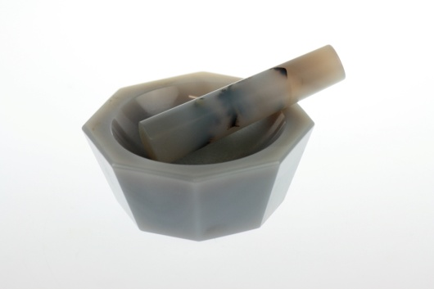

The …. ……. can The …….. is a dish and the …….
……… glassware. is the grinder. They are used to …..
or ….. chemicals.
2 You can see the pictures of the most frequently used pieces of glassware, porcelain
vessels and tools and other utilities. Look at them briefly and say:

- which of them you know
- which of them you have never seen
- which of them you like to work with

3 a) Sort this laboratory equipment into the columns:

goggles lab tongs pestle cylinder spot plate Petri dish thermometer balance funnel flask mortar polarograph evaporating dish test tube beaker desiccator furnace stirring rod watch glass pipet centrifuge crucible hydrometer ring clamp wire gauze burner flint lighter wash bottle hood spatula
conductivity tester weighing paper filter paper

glassware porcelain tools and utilities apparatuses
…................... ................... ............................ .......................
……............... .................... .............................. .......................
....................... .................... ............................. .......................
....................... .................... ............................... .......................
……............... .................... ............................ ......................
....................... .................... .............................. ......................
....................... .................... ............................. .......................
....................... .................... ............................... .......................
....................... .................... ............................... .......................
....................... .................... ............................... .......................

b) Work with a dictionary: find expressions concerning the laboratory equipment that
you still miss in the previous table and add them to the list.

c) Make sentences using the following verbs in connection with the laboratory
equipment from exercise 3a). Work in pairs.

place heat evaporate remove dissolve pour
splash scratch attach pick up insert support
anneal measure rinse separate crush grind
collect weigh fill stir fold ignite

4 Work in pairs or make a competition in teams. Choose 5 items of the lab equipment, prepare their description (material, shape colour, usage). Take turns in describing and guessing the defined objects.

5 Work in pairs or small groups: You are supposed to equip a chemical laboratory for the first year training at our school. With limited space and finance you have to agree on a list of 15 items that are indispensable.
When discussing which ones these should be, use various ways of expressing agreement or disagreement:
e.g.: I can’t agree, it can be replaced with....
Absolutely.
I agree with you, but...

6 Match the following verbs in column A with the nouns in column B.

A B
1. to evaporate A your eyes
2. to pour B a glass vessel
3. to measure C electricity
4. to separate D some water
5. to protect E a liquid into a container
6. to collect F gases inside
7. to conduct G chemicals
8. to support H the mass of an object
9. to scratch I a mixture
10. to transfer J the test tubes

7 Instructions for an experiment / Reporting actions (See Supplementary texts to
Unit 3).

WARM UP

8 Draw at least four signs you would put on the door of a chemical laboratory to inform the laboratory workers how to behave inside. Let your colleague guess the meanings of your signs. (Use modal verbs to express prohibition, recommendation, etc.)

9 Decide whether the following safety rules and recommendations are a GOOD, BAD or even DANGEROUS piece of advice.

- If you want to dilute sulphuric acid, pour water slowly into the acid.
- When working with unpleasant or dangerous vapours, plug your nose with cotton properly.
- If any chemicals get into your eyes, flush them with running water and inform the teacher or a colleague.
- In case of fire try to find some good shelter (e.g. under the sink) and wait.
- If you want to warm some meal in the lab, don´t put it in the furnace together with any chemicals.

10 Discuss the following questions:
  - Did you get any special training or preparation course before starting your laboratory sessions?
  - Did you have to pass any exam or obtain a credit connected with lab safety rules?
  - Have you ever witnessed any breaking of the safety rules in the lab? What happened?

11 Watch the Lab Safety video. In pairs or groups, how many rules can you remember?

READING COMPREHENSION

12 Study the text Lab Safety Rules and underline the expressions you are not familiar with. Can you guess their meaning from the context? If not, consult the dictionary.

13 Did any of the rules surprise you?

GENERAL GUIDELINES  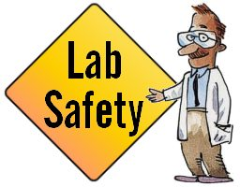    CLOTHING  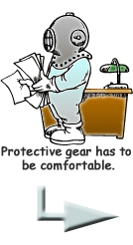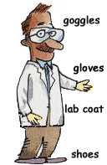  ACCIDENTS AND INJURIES    HANDLING CHEMICALS  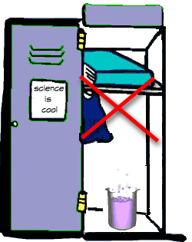 | 1. When first entering a science room, do not touch any equipment, chemicals, or other materials in the laboratory area until you are instructed to do so.  2. Never work alone in the laboratory. No student may work in the science classroom without the presence of the instructor.  3. Perform only those experiments authorized by your teacher. Carefully follow all instructions, both written and oral. Unauthorized experiments are not allowed.  4. Do not eat food, drink beverages, or chew gum in the laboratory. Do not use laboratory glassware as containers for food or beverages.  5. Be prepared for your work in the laboratory. Read all procedures thoroughly before entering the laboratory. Never fool around in the laboratory.  6. Always work in a well-ventilated area.  7. Observe good housekeeping practices. Work areas should be kept clean and tidy at all times.  8. Proceed with caution at all times in the laboratory. Notify the teacher immediately of any unsafe conditions you observe.  9. Dispose of all chemical waste properly. Never mix chemicals in sink drains. Sinks are to be used only for water. Check with your teacher for disposal of chemicals and solutions.  10. Labels and equipment instructions must be read carefully before use. Set up and use the equipment as directed by your teacher.  11. Keep hands away from face, eyes, mouth, and body while using chemicals or lab equipment. Wash your hands with soap and water after performing all experiments  12. Experiments must be personally monitored at all times. Do not distract other students or interfere with the laboratory experiments of others.  13. Know the locations and operating procedures of all safety equipment including: first aid kit(s) and fire extinguisher. Know where the fire alarm and the exits are located.  14. Know what to do if there is a fire drill during a laboratory period; containers must be closed, and any electrical equipment turned off.  15. Any time chemicals, heat, or glassware are used, students will wear safety goggles. NO EXCEPTIONS TO THIS RULE!  16. Contact lenses may be not be worn in the laboratory.  17. Dress properly during a laboratory activity. Long hair, dangling jewellery, and loose or baggy clothing are a hazard in the laboratory. Long hair must be tied back, and dangling jewellery must be secured. Shoes must completely cover the foot. No sandals allowed on lab days.  18. A lab coat or smock should be worn during laboratory experiments.  19. Report any accident (spill, breakage, etc.) or injury (cut, burn, etc.) to the teacher immediately, no matter how trivial it seems. Do not panic.  20. If you or your lab partner is hurt, inform the teacher immediately. Do not panic.  21. If a chemical splashes in your eyes or on your skin, immediately flush with running water for at least 20 minutes.  22. All chemicals in the laboratory are to be considered dangerous. Avoid handling chemicals with fingers. Always use tweezers. When making an observation, keep at least 1 foot away from the specimen. Do not taste, or smell any chemicals. If you need to identify a smell, cup your hand and waft.  23. Check the label on all chemical bottles twice before removing any of the contents. Take only as much chemical as you need.  24. Never return unused chemicals to their original container.  25. Never remove chemicals or other materials from the laboratory area.

TEAM WORK

14 Work in small groups and decide which of the rules are of the utmost importance. Make a TOP TEN list and reason your choice. Then report to the rest of the class.

15 Make a summary of the most important laboratory safety rules concerning the following facts:

- dress code for a laboratory worker
- refreshment during the lab period
- working with chemicals
- working with hot glassware
- what to do in case of injury
- what to do in case of fire

16 Read the Chemistry Poem. Do you know any poem, joke or anecdote about chemists, chemistry or labs?

Chemistry Poem
Poor Willie worked in chem lab. Poor Willie is no more.
For what he thought was H₂O was H₂SO₄!

FOLLOWING INSTRUCTIONS

17 Read the instructions on how to produce aspirin and fill in the gaps.

How to Make Aspirin - Acetylsalicylic Acid - Introduction and History

Steps 1-6 calculate weigh place add

pour cool destroy
- Accurately ………3.00 grams of salicylic acid and transfer to a dry Erlenmeyer flask. If you ……….. actual and theoretical yield, be sure to record how much salicylic acid you actually measured.
- ……. 6 ml of acetic anhydride and 5-8 drops of 85% phosphoric acid to the flask.
- Gently swirl the flask to mix the solution. ……. the flask in a beaker of warm water for 15 minutes.
- Add 20 drops of cold water dropwise to the warm solution to …….. the excess acetic anhydride.
- Add 20 ml of water to the flask. Set the flask in an ice bath to …….. the mixture and speed crystallization.
- When the crystallization process appears complete, …… the mixture through a Buchner funnel.

Steps 7-12 apply confirm remove minimize
transfer dissolve cover
- Apply suction filtration through the funnel and wash the crystals with a few milliliters of ice cold water. Be sure the water is near freezing to …….. loss of product.
- Perform a recrystallization to purify the product. …….. the crystals to a beaker. Add 10 ml of ethanol. Stir and warm the beaker to ……. the crystals.
- After the crystals have dissolved, add 25 ml of warm water to the alcohol solution. …….. the beaker. Crystals will reform as the solution cools. Once crystallization has started, set the beaker in an ice bath to complete the recrystallization.
- Pour the contents of the beaker into a Buchner funnel and …….. suction filtration.
- Transfer the crystals to dry paper to ………. excess water.
- ……… you have acetylsalicylic acid by verifying a melting point of 135°C.

VOCABULARY

yield - the quantity of a product formed by the interaction of two or more substances
swirl - to move around or along with a whirling motion
excess - too much of something
suction - to draw out or remove by aspiration
loss - something that is lost
confirm - to acknowledge with definite assurance
verify - to prove the truth of, as by evidence or testimony; confirm

18 Make a list of all the items of laboratory equipment you need for this experiment.

WRITING

19 Choose one of the experiments you really performed in the laboratory and write down the instructions of the procedure. (minimum: 10 steps)

LEXICAL EXERCISES

20 Look again at the instructions for making aspirin in exercise 17, namely steps 8 and 9 containing the words recrystallization and reform. What is the meaning of the prefix re- in those words?

21 A Use 8 of the following prefixes to fill the gaps.
dis- en- im- inter- mono- nano- pre- semi- ultra- un- micro-

_____cellular space serves for gas to be exchanged between cells.
_____capsulated drugs are used for targeted delivery, i.e. the capsule dissolves and releases its contents when it reaches the required location.
_____tubes have a diameter smaller than 200 x 10⁻⁹ meters.
_____structure is the detailed structure of biological specimen, such as a cell, tissue, or organ, that can be observed by electron _____scopy.
Often it is impossible to _____determine the specific problems that researchers will meet during their laboratory work.
_____basic acids, such as HCl or HNO₃, are acids that have only one hydrogen ion to donate to a base in an acid-base reaction.
Trans fatty acid is commonly produced by partial hydrogenation of _____saturated fatty acid vegetable oils.

B Explain the meaning of the prefixes.

C Make words with the remaining 3 prefixes and use them in sentences.

22 Work in pairs.
Student A: Fill in table A
Student B: Fill in table B on the Activity Sheet (end of Unit 3)
Check the ansers with your partner. Can you think of any other example?

Table A

Prefix | Meaning | Example | Prefix | Meaning | Example
a-/an- |  | asymmetric | milli- | 1/1000
auto- | self |  | mono- |  | monocellular
bi- |  | bisulfate | multi- | many
bio- | living |  | re- |  | reset
co- |  | cooperate | semi- | half
hydro- | water |  | tri- |  | tripod
kilo- |  | kilogram | ultra- | very
micro- | small |  | un- |  | unknown

23 Study the Common Affixes section of the Grammar File.

24 Fill in the table:

Noun | Verb
preparation | to prepare
determination
modification
application
condensation
adsorption
filtration
 | to dissolve
 | to analyse
 | to observe
 | to heat
cold
change
 | to spill
comparison
synthesis
identification
degradation

SEARCHING FOR AND SHARING INFORMATION

25 Recrystallization is just one of a number of separation methods and processes. Choose one of those listed below and search the Internet for information. Then write 5 key words on the board and do a mini-presentation on your findings to the class, giving the most important details (what the method or process is based on, how it works, where it is used).

Adsorption, centrifugation, chromatography, decantation, distillation, drying, electrophoresis, extraction, flocculation, filtration, magnetic separation, precipitation, recrystallization, sieving, stripping, zone melting (also called zone refining).

TEXT BUILDING

26 Work in pairs. Go back to Unit 2 ex. 21 and look at the underlined words in the text. What is their role? Assign the words to the relationship categories shown in the table below:

Relationship | Linking word or expression
Addition | and, in addition, moreover, also, as well
Contrast | despite, in spite of, in contrast, while, nevertheless, on the one hand……on the other hand, not only……but also
Reason | due to, because of
Purpose | in order to, so as to, with the aim of, so that
Result | consequently, as a result
Condition | unless, otherwise, as long as
Similarity | similarly
Summary | on the whole, on balance
Other

27 What are the rules? Choose the correct options.

In formal writing, so/therefore is used only to connect ideas within one sentence, while so/therefore can be used in a single sentence or to connect two sentences.
Sentences do not usually begin with therefore/but in written English. The same is true for becouse/since.
You should not use in addition/and to start a sentence when you are writing a scientific paper.
Although most linkers are followed by a verb clause, because of, despite and in spite of /because, although and however are followed by a noun or an –ing form.

28 Choose the best alternatives to complete the “teenager’s kitchen experiment”.

If/Because you put an egg in a container with vinegar, the egg shell will soften and, after certain time, disappear. The explanation is as follows.
Egg shells are quite hard because/because of they contain calcium carbonate. But/However, vinegar contains C₂H₄O_{2;} due to/because that, the acid reacts with the calcium carbonate, and/in addition carbon dioxide is released, forming bubbles in the vinegar. The chemical reaction continues until all the carbon is used up. It is not a very fast process because/therefore C₂H₄O₂ is a weak acid. Nevertheless/In contrast, after a day or two the shell dissolves completely. The egg is then soft as/so as to all of the carbon floated out of the egg in those little bubbles.
Once/Despite you take the egg out of the container and leave it exposed to air, a reverse reaction will start. The calcium remaining in the egg shell will bond with the carbon from the carbon dioxide in the air. In order to/As a result, the egg becomes hard again.
Similarly/On balance, you can experiment with e.g. chicken bones. Immerse them in vinegar in order to/whereas make them soft. Consequently/But, you will be able to bend them, make different shapes of them, or even tie them in a knot. Take them to school so that/although your friends can share the amusement. Unfortunately/Accordingly, there is no guarantee that the bones experiment will improve your chemistry school mark, but at least it will be fun.

29 Look at the sentences in ex. 28 and decide wheather the following punctuation statements are true or false.

Words connecting two sentences (e.g. Similarly, In addition, etc.) are usually followed by a comma.
There is never a comma before and.
Except for inserted clauses, there is usually no comma before if.
Usually there is no comma before because.
Usually there is no comma before but.

30 Transform the sentences, using the words given.

The shell dissolved because the liquid was acidic.

(because of)
(as)
(therefore)

Although we have run the separation process several times, we have not been able to obtain a pure substance.
(despite)
(nevertheless)

You must dilute the mixture, otherwise the concentration will be too strong.
(in order to)

The temperature was too high and the liquid evaporated.
___________________________ ________(because)
__________________________________ _(since)
____________________________________(due to)
LISTENING

31 Before listening, discuss the following questions:
- Do you use any plasticware in your laboratory?
- Do you expect plasticware to be affected by chemicals more easily than glassware?

32 Listen to the recording and decide whether these statements are true (T) or false (F). Correct the false ones.

a. The scientists expected the influence of ammonium chloride concentration in reaction with an enzyme linked to Parkinson’s disease.
b. This influence has been confirmed.
c. The scientists found several chemicals that came out of the polypropylene containers.
d. Di HEMDA is used to stop anything growing in the container.
e. Oleamide has similar usage as Di HEMDA.
f. These experiments proved plasticware not to be generally suitable for laboratory work.
g. Plasticware will not be used in laboratories in future.

33 Listen again; this time follow the transcription of the interview and fill in the missing words.

Interviewer - Chris Smith
Now to a way in which our experiments could be thrown into disarray, Matt tell us about this.
Interviewee - Matt Wilkinson
Yes, a team of Canadian ………………….. led by Andrew Holt at the University of Alberta have shown how chemicals leaching from plasticware can actually ………………….. the reactions that you do in them dramatically.
Interviewer - Chris Smith
So what were they doing? How did they find it?
Interviewee - Matt Wilkinson
Well, they were initially studying how an enzyme linked to Parkinson's disease, reacted with ammonium chloride, and surprisingly they found that it didn't seem to ………………….., how much they diluted that ammonium chloride, the ………………….. were still there.
Interviewer - Chris Smith
So something was amiss. How did they try to find out what it really was?
Interviewee - Matt Wilkinson
What they did was that they started off by seeing if they could extract anything from the ………………….. themselves and they found that there were two chemicals in particular that came out of the polypropylene containers, while they were doing these reactions that seemed to inhibit the enzyme. One of these is the disinfectant DiHEMDA, which is used to stop anything growing in the containers, while they're in ………………….. and the other is the lubricant, oleamide, that's used to stop the packages from sticking together during the ………………….. process.
Interviewer - Chris Smith
So where were these chemicals coming from? Were they actually in the plastic itself?
Interviewee - Matt Wilkinson
They're actually in the plastic themselves.
Interviewer - Chris Smith
And do we know how they were interfering with the chemical reaction that the researchers were trying to …………………..?
Interviewee - Matt Wilkinson
They've actually found that both of these chemicals are inhibitors of the enzyme itself.
Interviewer - Chris Smith
And this is obviously a bit of a canary in the cage, saying there are things in these plastic containers that could affect other reactions. Do they speculate as to how well this could throw a spanner in your scientific works?
Interviewee - Matt Wilkinson
Well, yes it kind of throws a spanner into any reaction that you're doing, that's ………………….. sensitive. If you're using any kind of plasticware from a container, through to a pipette, any plastic has the potential to leach some of its constituent chemicals out of it, the most interesting thing, I think, about this of course is that people have started using ………………….. plasticware to avoid the problems of incomplete cleaning of glassware.
Interviewer - Chris Smith
So, is this the death knell for laboratory plasticware then?
Interviewee - Matt Wilkinson
No, absolutely not, I think that it really emphasizes the need to run controlled experiments as we all should do anyway and you need to seriously control the plasticware that you do use, so that you can actually make sure that conditions are kept exactly the same.
Interviewer - Chris Smith
So maybe it's not always true the bad workman blame their ……... Thank you for that Matt.

34 Use the words you filled into the text in your own sentences

35 Compare the use of glassware and plasticware in the lab. Think of any pros and cons and draw a conclusion, using some of the linking words from the Text Building section (ex.26).

VOCABULARY GAME

36 Work in small groups (3-4 people). Each group will be given a slip of paper with one word. Make a sentence which uses the word correctly, but instead of saying the word, say blip. If the other groups cannot guess the word, another member of your team makes another sentence with the same word.
Example: Water blip when heated to 100ºC.

A FACT OF LIFE
If you're not part of the solution, you're part of the precipitate!

GRAMMAR LINKS

Grammar File – Common Affixes and English Specific Infinitive Structures.

ACTIVITY SHEET

Ex. 22 Student B

Table B
Prefix | Meaning | Example | Prefix | Meaning | Example
a-/an- | without |  | milli- |  | millimetre
auto- |  | automation | mono- | one
bi- | two |  | multi- |  | multilevel
bio- |  | biology | re- | again
co- | together |  | semi- |  | semimetal
hydro- |  | hydrolysis | tri- | three
kilo- | 1000 |  | ultra- |  | ultraviolet
micro- |  | microscope | un- | not

UNIT 4

ENVIRONMENT

WARM UP
1 Match the words to make collocations and give their definitions.

1) greenhouse a) growth
2) recycling b) warming
3) population c) effect
4) climate d) disasters
5) groundwater e) rain
6) environmental f) pollution
7) alternative g) changes
8) global h) sources
9) acid i) problems
10) natural j) energy

1…, 2…, 3…, 4…, 5…, 6…,7…, 8…, 9…,10…

SPEAKING

2. Discuss in pairs or in small groups the following statements.
- 10 ways how to save our planet
- What is your greatest environmental concern, and why?
- Common types of alternative energy – definitions and resources (e.g. solar power, wind power, offshore wind power, hydro-electric power, geothermal energy, tidal power, hydrogen, biofuel, ethanol, biomass, … )
- What should governments do to tackle pollution?
- Nuclear energy plants are the most sophisticated and complex energy systems ever designed.

3 Prepare some interesting news connected with environmental protection.

Use different sources e.g. the latest news , the Internet, newspaper articles or professional
magazines. Present the news briefly and discuss it in the class.

PRE-READING

4 Match the following words with their definitions.

1. current a) in the sea or on the land near the coast

2. spatial b) the way the sea moves up and down

3. coastal c) on or near the land rather than in the sea

4. leap d) a continuous movement of water in a particular direction in a river or in the sea

5. contribution e) a big jump

6. floating f) being related to space

7. onshore g) something that you do in order to help something be successful

8. swell h) an object is not properly connected or is not in the usual place

1…, 2…, 3…, 4…, 5…, 6…, 7…, 8…

READING

5 Read the following article.

Offshore wind energy

Offshore wind is one of the most promising and climate-friendly energy-producing technology in the world. It is definitely the least-expensive energy source in many or even most regions now.
Offshore wind power refers to the construction of wind farms in water areas such as lakes, fjords and sheltered coastal areas to generate electricity from wind, utilizing traditional fixed-bottom wind turbine technologies, as well as deep-water areas utilizing floating wind turbines.
A range of spatial and temporal scales and external conditions limit the potential location of offshore wind plants. These data includes water depth, currents, seabed migration and wave action. There are also further factors such as marine growth, salinity, icing and definitely geotechnical characteristics of the sea or lake bed. Corrosion is also a serious problem and requires detailed design considerations.
Strong wind speeds are available offshore compared to on land, so offshore wind power´s contribution in terms of electricity supplied is higher. Offshore wind is steadier, more consistent and not blocked by mountains, trees, buildings, etc. Additionally, offshore wind farms can actually be built closer to most population centres than onshore wind ones. New systems allow to install turbines in deep waters, lift heavier weights, cope with bigger swells and carry more machines out to wind-farm sides.
The next leap is the technology of solar-wind hybrid power plants that are seemingly twice as efficient. This energy system uses two renewable energy sources used together to provide increased system efficiency as well as greater balance in energy supply. One of the strongest benefit is that the constructions of solar photovoltaic systems and wind turbines installed together do not require grid expansion since the plants generate solar and wind power at different intervals and during complementary seasons.

Some facts about offshore wind energy :
- The first US offshore wind turbine was launched in May 2013
- The EU installed more than 1 offshore wind turbine per working day in 2012
- Europe will install about 10.4 gigawatts offshore wind turbines, it will be more than 70% of the global total
- £35b offshore wind contribution by 2050
- $232 - a megawatt per hour is power - generation production cost

READING COMPREHENSION

6 Answer the following questions according to the text.
- Which water bodies are commonly used for wind plants?
- What are the types of turbines?
- What are the factors which determine the location and the construction of offshore wind plants?
- What is the efficiency of solar-wind hybrid power plants?
- What are the main benefits of solar-wind hybrid power plants?

7 Make your own sentences using the words given in the text in bold.

8 Explain the meaning of these words from the text.
to cope with …………………………………………………………………………..
complementary ……………………………………………………………………….
consideration …………………………………………………………………………
to launch ……………………………………………………………………………...

utilizing ……………………………………………………………………………....
grid …………………………………………………………………………………….
potential ……………………………………………………………………………….
to generate ……………………………………………………………………………

VOCABULARY

9 Choose the suitable expression for each sentence.

1. People are becoming more concerned …………environmental matters.
a) in b) to c) on d) about

2. Many species of wildlife could become ……………….if left unprotected.
a) endangered b) in danger c) extinct d) dangerous

3. In some cities a poisonous smog is created ……….. car exhaust fumes.
a) from b) by c) to d) of

4. ……..-exploitation of fossil fuels such as coal and oil will lead to an energy crisis.
a) Re b) Over c) Non d) Un

5. Factories often dispose …….. waste products in rivers and the sea.
a) on b) - c) of d) off

6. The indiscriminate use of chemical fertilizers, pesticides and other chemicals has …….
sources of groundwater.
a) destroyed b) devastated c) vanished d) abolished

7. Water pollution occurs when pollutants are directly or indirectly discharged ………
water bodies e.g. lakes, rivers, aquifers and groundwater.
a) with b) in c) into d) out of

8. Cities with sanitary sewer overflows or combined sewer overflows employ one or more
engineering approaches ……… reduce discharges of untreated sewage.
a) to b) for c) from d) at

9. Sampling of water for physical or chemical testing can be done by several methods,
depending …….. the accuracy needed and the characteristics of the contaminant.
a) in b) on c) with d) to

10. Retention basins tend to be less effective ……. reducing temperature, as the water may be
heated by the sun before being discharged to a receiving stream.
a) at b) in c) with d) for

READING

10 Read the following text and fill it with appropriate forms of words given in brackets.

Facts about drinking water

Drinking water is such a vital and ………………….(fundamentalism) part of our lives that we have a tendency to take for granted that our water is safe to drink.
- Water ……………. (consume) has almost doubled in the last 50 years. A child born in the developed world consumes 30 to 50 times the water resources of one in the ………………… (develop) world.
- Water supplies are falling while the demand is………………… (drama) growing at an
unsustainable rate. Over the next 20 years, the average supply of water worldwide per person is expected to drop by a third.
- Over 1.5 billion people lack ready access to drinking water, and, if current consumption patterns continue, at least 3.5 billion people nearly half the world´s projected …………… (populate) will live in water – stressed rivers basins in just 20 years.
- Drinking water …………………. (contaminate) is a growing problem worldwide and dwindling freshwater resources are under ………………….(increase) pressure due to pollution and population ………………(grow).
- Water………………….. (purify) is necessary due to many factors of pollution such as manufacturing,……………….. (agriculture) accidental and consumer pollution. Some common sources of water pollution include :
- surface runoff from farms, businesses and paved surfaces
- excess of nutrients pumped into waters
- discharge of used water into waters
- acid rain
- underground storage tank……………. (leak)
- discharge of used chemicals into waters
- discharge of industry by-products into waters
- toxic…………………. (contaminate) form underground storage tanks
- bacteria, viruses and parasites
- wasteful use of water.

VOCABULARY

11 Create adjectives from the following words.
save - ……………………
accident - ……………………
environment - ……………………
pollute - ……………………
filter - ……………………
grow - ……………………
provide - ……………………
response - ……………………
purify - ……………………
nature - ……………………

12 Create nouns from the following verbs.
purify - ……………………
consume - ……………………
produce - ……………………
develop - ……………………
expect - ……………............
grow - …………………....
contaminate - ……………………
monitor - ……………………
pollute - ……………………
contribute - ……………………

LISTENING

Chemical vs. Biological Wastewater Treatment (Part 1)

13 Listen to the recording and decide whether these statements are true (T) or false (F).
Correct the false ones.

- In the resulting wastewater we have collected organic matter and nutrients such as phosphorus and nitrate.

- These problems are actually caused by an unnaturally high consumption of oxygen, but if nutrients such as phosphorus and nitrogen are discharged into a water, they provide food source for algae and plankton.

- At other locations a discharge of phosphorus and nitrogen could cause intensive damage to the environment since it can initiate biological growth.

- Since only one-third of the organics will be removed by this process, biological or chemical purification is supplemented in order to meet increased requirements.

- Let´s compare these methods. We stopped them at the same time and discovered that chemical precipitation cleans the water very rapidly, less than fifty minutes after the indication of the process.

14 Listen to the recording again, this time follow the parts of the transcription
and fill in the missing words.

1. The organic matter immediately starts to consume ……………… in the water,
resulting in an oxygen deficiency, which …………… leads to the deaths of fish.

2. This new biomass is in fact an organic matter and ……………………. this, we
have an additional ………………….. of oxygen.

3. It is therefore of vital …………………… that the regulations for discharge permits and
choice of purification methods comply with the……………………. prerequisites.

4. This is a simple process when large………………….. sink to the bottom and formed
…………………… .

5. We have cleaned water with a biological process. It would take ……………. hours to
obtain the same result. The biological ………………. lasts a comparatively long time.

LISTENING COMPREHENSION - WRITING

Chemical vs. Biological Wastewater Treatment (Part 2)

15 Watch the video, listen to it carefully and make notes. Watch the video twice.
Write a short summary about the content of the video. ( approx.50 words)

VOCABULARY - REVISION

16 This crossword will help you learn some new words or revise those that you should already know.

Across

2. the most abundant element in the universe; it can be used as a fuel source
5. energy that can be reused an infinite number of times
6. a period of time that is different from the others because of particular characteristics
or events
7. a car that uses a combination of electricity and gasoline
8. an interdependent community of organisms including plants, animals, water, air and the
ground
9. the term given to food sold in supermarkets and grown without synthetic
fertilizers, chemicals and antibiotics
10. another name for buyers; they can influence what products are carried in stores

Down

1. the most abundant energy capable of being harnessed by humans
3. the name given to gasses that trap heat and cause global warming
4. one of the factors that causes global warming, desertification

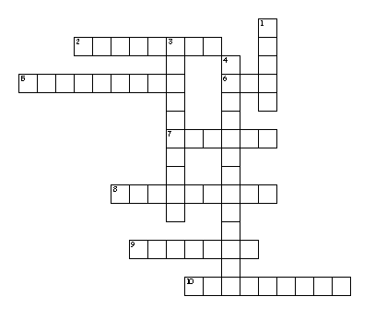

LEXICAL EXERCISE

PHRASAL VERBS

17 Study the structure of phrasal verbs.

Phrasal verbs:
- can be literal or idiomatic
- are formed by verb + particle: The plan didn't work out., The plans fell through.
- or verb + particle + object: He took away the materials., They put off the meeting., Do not let me down., He came across an anti-eco ad.
- or verb + particle + particle: I am looking forward to leading the campaign., How can you put up with their policy?

18 Match the phrasal verbs from the sentences above with their synonyms for better
understanding.

1. run on a) to put something in order, to tidy and organize something

2. do away with b) to reduce the amount or quantity of something

3. run out c) to stop using something gradually or in stages

4. give off d) to use a particular type of power or fuel to make a machine or
a vehicle work

5. phase out e) to stop doing or having something or to make something
no longer necessary

6. sort out f) to produce something such as heat, light, smoke,etc.

7. throw away g) to use up or finish a supply of something

8. cut down h) to think of an idea, an answer to a question or a solution
to a problem

9. run into i) to get rid of something

10. come up with j) to reach a particular level, amount or state

1…, 2…, 3…, 4…, 5…, 6…, 7…, 8…, 9…, 10…

19 Fill in the gaps to form appropriate phrasal verbs.

1. Our cities would be cleaner if cars could run __________ electricity instead of petrol.
a) on b) in c) at
2. According to some experts all countries should do __________ nuclear energy completely.
a) for b) away with c) out off
3. All non-renewable fuels will eventually run _________ .
a) down to b) out at c) out
4. Safety is an important issue for petro-chemical companies.Some of the chemicals they
produce give _____ toxic fumes, so they have to ensure they are not spiltor released into
the environment.
a) off b) under c) up
5. The government is planing to phase _______ all diesel powered cars by the year 2015.
a) off b) on c) out
6. The recyclable material is sorted ______ and carried to another location for recycling.
a) out b) up c) in
7. The Minister chairs a committee aiming to improve the way we throw_______rubbish
from our homes.
a) down b) away c) off
8. It is necessary to cut _______ carbon dioxide emissions.
a) up b) away c) down

9. Their solar panel business ran_______ problems after a succession of wet summers
in the mid –nineteen nineties.
a) out of b) down c) into

10. A team of American scientists have come __________ a method of water purification.
a) into b) up with c) over

VOCABULARY

20 Match the words with their definitions.

1) crude oil a) a saturated hydrocarbon; it consists
of hydrogen and carbon atoms

2) reservoir b) a gas without colour or smell that
burns easily and used as a fuel

3) natural gas c) a large amount of something that
is available to be used

4) methane d) oil in its natural state before it has been
treated with chemicals

5) alkane e) the simplest alkane and main
component of natural gas

1…, 2…, 3…, 4…, 5…

LISTENING

OIL AND GAS WELLS – START TO FINISH

21 Listen to the recording and decide whether the statements are true (T) or false (F).
1. Heavy drilling mud can circulate without the control of underground pressure.
2. About 68,000 oil and gas wells were drilled in the States in 1954 – 1980.
3. Most oil and gas wells are drilled through water zones and then oil, gas and water
must be mixed.
4. According to the type of reservoir in pressure different kinds of production
equipment are installed.
5. To abandon the well cement is placed across oil zones.

22 Make sentences by putting the expressions in the correct order.

1. wells / crude oil / into the underground / Extracting / normally / reservoir / starts with
drilling
…………………………………………………………………………………………….
…………………………………………………………………………………………….

2. to the surface / is created by / a long hole / The oil well / drilling / which pumps /
into the earth / with an oil rig / the oil
……………………………………………………………………………………………
……………………………………………………………………………………………

3. a byproduct / can be / almost / on the other hand / Natural gas / always / is /
of production oil / natural gas / unwanted / a disposal problem /
…………………………………………………………………………………………..
…………………………………………………………………………………………..

4. consisting / commonly / Natural gas / mixture / higher alkanes / a hydrocarbon gas /
primarily / carbon dioxide / includes / of methane / hydrogen sulphide / and / nitrogen /
and / is
………………………………………………………………………………………….
………………………………………………………………………………………….

5. also / of the drill pipe / Drilling fluid / mud / and / at the drill bit / called / is pumped /
down the inside / exits /
………………………………………………………………………………………….
………………………………………………………………………………………….

6. chemicals / is / solids / a complex mixture of / Drilling mud / fluids / and
………………………………………………………………………………………….

7. of the reservoir / for oil and gas / In many wells / to flow / enough / the natural gas /
is / to the surface / pressure / high
………………………………………………………………………………………….
………………………………………………………………………………………….

8. are used / the reservoir pressure / water flooding / To increase / or / CO₂ flooding /
enhanced recovery methods / steam flooding / such as
………………………………………………………………………………………….
………………………………………………………………………………………….

