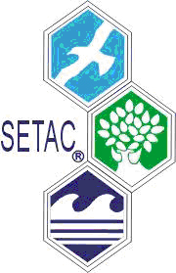
SETAC EU
Central & East branch

Life Cycle Assessment
in Prague

LCA platform in Czech Republic and Slovakia

Date: October 31st, 2006
Prague, Czech Republic
Conference language: Czech and Slovak

The 1st local LCA conference organized in Czech Republic and Slovakia is focused on insightful introduction into assessment on environmental impacts of products and services. New methodology of environmental evaluation of products in relation to EN ISO 14040 – 14049 guidelines will be presented. General introduction into all phases of LCA together with a particular interest in Impact categories will be offered to participants.
All practitioners interested in Ecodesign, Ecolabeling, Life Cycle Management, Life Cycle Costing, Life Cycle Thinking are welcomed, too.

For an abstract submission, please, contact: Vladimír Kočí, SETAC EU Central & East branch, ICT Prague, 166 28 Technická 5, Prague 6, Czech Republic. Vladimír.Koci@vscht.cz

---------------------------------------------------------------- --------------------------------------------------------------------------

If you plan to plan to Join LCA in Prague conference, please, send this on address:

Vodní zdroje Ekomonitor spol. s r.o., Píš‘tovy 820, 537 01 Chrudim 3, Czech Republic

Or via e-mail: mouckova@ekomonitor.cz

LCA in Prague
Name and Surname:
Institution:
Address:

Tel.: | Fax: | E-mail:
Your comments:

